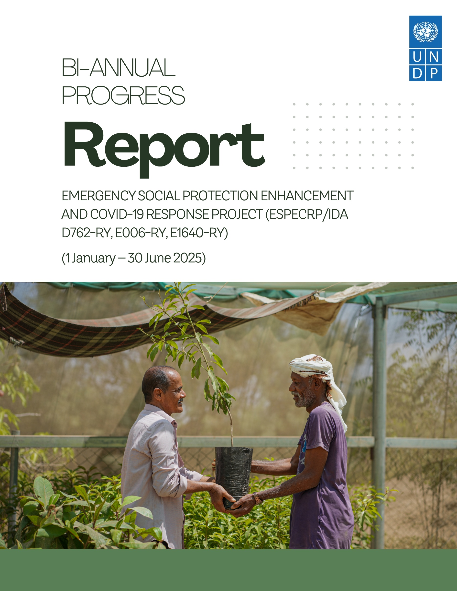
ABBREVIATIONS AND ACRONYMS
AF  BA  BC  CC  CBY  CFW  CFN  CHE  Houthis  ESAP  ESMF  ESMP  ESPECRP  ESRM  FTO  GB  GBV  GM  HH  IDA  IDPs  IFPRI  IRG  IPs  ISM  LTA  MIS  MFIs  OFAC  OHS  OTP  PAD  PDO  PWD  PF  PFI  PSEA  PGM  PWP  RVM  SFD  MSME  SMED  SMEPS  SWF  TA  TFC  ToR  TPMA  UNDP  US$  WB  YER  YLG | Additional Financing  Business Association  Business Cooperative  Community Contracting  Central Bank of Yemen  Cash for Work  Cash for Nutrition  Community Health Educator  Houthi Movement  Environmental and Social Action Plan  Environmental and Social Management Framework  Environmental and Social Management Plan  Emergency Social Protection Enhancement and COVID-19 Response Project  Environmental and Social Risk Management  Foreign Terrorist Organizations  Geobundling  Gender-Based Violence  Grievance Mechanism  Household  International Development Association  Internally Displaced Persons  International Food Policy Research Institute  Internationally Recognized Government of Yemen  Implementing Partners  Implementation Support Mission  Long Term Agreement  Management Information System  Micro Finance Institutions  Office of Foreign Asset Control  Occupational Health and Safety  Outpatient Therapeutic feeding Program  Project Appraisal Document  Project Development Objective  Person with Disability  Parent Fund  Partner Financing Institution  Prevention of Sexual Exploitation and Abuse  Portfolio Guarantee Model  Public Works Project  Remote Verification Mechanism  Social Fund for Development  Micro, Small and Medium Enterprise  Small and Micro Enterprises Development  Small and Medium Enterprise Promotion Services  Social Welfare Fund  Technical Assistance  Therapeutic Feeding Center  Terms of Reference  Third Party Monitoring Agency  United Nations Development Programme  United States Dollar  The World Bank  Yemeni Riyal  Yemen Loan Guarantee

Contents
1. Executive Summary 4
2. Major Events 5
3. Progress of Project Development Objectives (PDOs) 7
4. Financial management and disbursement status 8
5. Progress by Subcomponent 10
5.1 Subcomponent 2.1 Cash for Nutrition (CFN): 10
5.2 Subcomponent 2.2 Cash for Work (CFW) 13
5.3 Subcomponent 2.3 Community Assets (CA) 16
5.4 Subcomponent 2.4: Economic Opportunities and Food Market Resilience 21
5.4.1 Subcomponent 2.4a Increased Access to finance for MSMEs 21
5.4.2 Sub-component 2.4b Direct support to MSMEs and Business Associations in Critical Sectors 23
6. Component 2 Project Management, Monitoring, Evaluation and Capacity Building of National Institutions 25
7. Monitoring and Evaluation 29
8. Social and Environmental Risk Management (Detailed report in this link) 32
9. Communication & Visibility Plan 39
10. Key Actions/Activities for the Next Reporting Period (July to December 2025) 41
11. Risk Framework and Risk Mitigation Measures 42
12. ANNEXES: 44
Annex 1: Results Framework 44
Annex 2: Annual Progress (Expenses and Direct Beneficiaries) per Subcomponent 47
Annex 3: Subcomponent Intermediary RRF by Financing Agreemen, as of 30 June 2025 48
Annex 4: Communication and Visibility Reference Links 49

Executive Summary

This biannual progress report summarizes implementation of the Yemen Emergency Social Protection Enhancement and COVID-19 Response Project (ESPECRP) during January–June 2025. The project is implemented by UNDP through three national institutions defined as the Implementing Partners (IPs): the Social Fund for Development (SFD), the Small and Micro Enterprise Promotion Service (SMEPS), and the Public Works Project (PWP).
The Project Development Objective (PDO) aims to provide cash transfers, temporary employment and enhanced access to basic services for food-insecure populations impacted by COVID-19, conflict, and climate-related shocks, while also strengthening national institutions. The project continues to operationalize the Geobundling model, layering multi-sector interventions in high-need localities for maximized impact.
As of 30 June 2025, cumulative disbursement reached 67.4 percent of the US$ 232.9 million across the three financing agreements. Project performance remained strong, with over 131,000 households receiving nutrition-sensitive cash assistance (exceeding targets by 23 percent), 114,316 individuals benefiting from temporary employment, and 1.17 million people gaining improved access to services such as water, sanitation and roads. The project also supported 9,459 Micro, Small, Medium Enterprises (MSMEs), including over 2,400 women-led enterprises, enhancing local food systems and economic resilience.
The women, youth, and Internally Displaced Persons (IDPs) have been engaged across all subcomponents, with steady progress against the set targets. At the community level, 87 subdistricts are under implementation, with 1,318 Village Cooperation Councils (VCCs) and 119 Sub-District Development Committees established through participatory processes. These structures, which have near gender parity, have strengthened local ownership, improved gender inclusion and accountability. Environmental and social safeguards have been maintained, with compliance supported by field monitoring and third-party verification.
The operating context remained challenging. The U.S. re-designation of the Houthis as a Foreign Terrorist Organization (FTO) disrupted financial flows and operations in Houthi-controlled areas. Temporary UN activity suspensions in Sa’ada, sanctions on the Yemen Kuwait Bank, and liquidity constraints impacted delivery. To mitigate this, the project adopted alternative banking channels, adaptive modalities, and targeted reallocations to maintain delivery.
Looking ahead, the project will focus on accelerating implementation under AF2, strengthening institutional capacity, and promoting climate adaptation, women’s economic empowerment, and sustainable livelihoods, while continuing to manage operational and fiduciary risks. ESPECRP continues as a vital platform for supporting recovery and resilience in Yemen’s fragile context.

Major Events

FTO re-designation of the Sana’a-based Houthis:
In March 2025, the United States re-designated the Houthis as a Foreign Terrorist Organization (FTO), significantly increasing legal, financial, and operational risks for ESPECRP activities in areas under Houthi control. This move led to heightened compliance requirements, banking disruptions, and delays in fund transfers to implementing partners, particularly in the North. Several banks relocated their headquarters to Aden to mitigate sanctions-related exposure, further complicating access to financial services across conflict lines.
To address these risks, UNDP implemented a range of mitigation measures including shifting transactions to non-sanctioned banks, limiting cash advances, adopting direct payment and reimbursement modalities, and ensuring alignment with Office of Foreign Asset Control (OFAC) General Licenses for humanitarian activities. These efforts aimed to maintain programme continuity while safeguarding compliance and minimizing disruption to ESPECRP operations.
Escalations by the USA and Israel against the Houthis:
The Houthis escalated missile and drone attacks on Red Sea shipping in response to the Gaza conflict. The United States launched an operation with a series of targeted airstrikes against Houthi military infrastructure, aiming to safeguard international maritime navigation.
By April, a de-escalation agreement mediated by Oman allowed U.S. ships safe passage, easing tensions. Israel also conducted retaliatory strikes on Houthi-linked sites in Yemen. The escalation raised significant regional tensions and disrupted global shipping routes. Although ESPECRP operations were not directly affected, the situation underscored the need for ongoing risk monitoring and adaptive planning amid volatile regional dynamics.
Suspension of operations in Sa’ada:
Following the detention of eight additional UN personnel by the Houthis in February 2025 – six of whom were operating in Sa’ada – the UN temporarily suspended all operations in the governorate to ensure staff safety. While this pause aimed to create space for dialogue and secure detainee releases, its impact on ESPECRP was limited, as most subprojects in Sa’ada were either completed or had not started. Only two subprojects (worth approx. US$ 298,000) were paused.
With no resolution yet, UNDP and partners are considering reallocating the remaining Sa’ada funds (approx. US$1 million) to other eligible governorates under the geobundling framework.
Banking Crisis and Its Operational Impacts on ESPECRP:
In early 2025, Yemen’s banking sector faced severe disruptions due to escalating tensions between the Central Banks in Aden and Sana’a, compounded by international sanctions. The de-licensing of key banks, including the UN's primary partner IBY (International Bank of Yemen), led to liquidity shortages and restricted access to funds. Sanctions on Yemen Kuwait Bank (YKB) and the FTO re-designation of the Houthis further complicated transactions, risking fund freezes and compliance challenges.
In response, UNDP and other UN agencies shifted to alternative banks (Kuraimi Islamic Bank and Yemen Commercial Bank), introduced direct payment and reimbursement methods, and explored additional channels like money exchange networks. Coordination with both Central Banks of Yemen (CBYs), continued donor dialogue, and contingency banking options were also pursued. While these measures have stabilized operations for now, the financial landscape remains fragile and will require close monitoring and adaptive planning going forward.

Bank-Imposed Liquidity Charges
During the reporting period, UNDP Yemen assessed the impact of new liquidity charges (up to 1.75 percent) imposed by commercial banks on USD transactions, driven by ongoing market constraints. These charges affect the value of project funds, and several donors have confirmed them as ineligible for reimbursement.
Following consultations with IPs, UNDP agreed to continue USD disbursements, with IPs responsible for negotiating any associated charges and converting funds to YER or SAR at agreed exchange rates. Reverting to YER payments was deemed riskier due to currency volatility and liquidity challenges, especially in the North. UNDP and IPs continue to monitor the situation and will adjust as needed to uphold compliance and delivery efficiency.
Outstanding project fund at the Yemen Kuwait Bank (YKB) sanctioned:
On 17 January 2025, OFAC sanctions on YKB led to USD 2.3 million in PWP project funds being frozen. Through an agreement with YKB to gradually release the blocked funds through weekly instalments of USD 100,000–150,000, the outstanding balance was reduced by more than half to USD 1.03 million as of end April 2025. However, YKB later halted further disbursements due to liquidity issues and sanctions.
The World Bank has requested full resolution or reimbursement of the outstanding amount by 31 October 2025. UNDP remains in active dialogue with YKB and is pursuing all channels, including a possible OFAC exemption, to recover the funds within the deadline.
Implementation Support Mission (ISM):
The World Bank conducted a virtual Implementation Support Mission (ISM) with UNDP and the implementing partners for ESPECRP from 23 to 25 June 2025. The mission reviewed overall implementation progress, with particular attention to achievements across components and performance against the Results Framework. It assessed compliance with fiduciary requirements—including financial management, disbursement, and procurement—and examined the management of environmental and social safeguards. The mission also considered the latest Third-Party Monitoring (TPM) findings, analyzed key implementation risks, and received an update on the status and next steps for the proposed fourth Additional Financing (AF4).
The mission concluded that, despite a volatile political and security context, the project maintains strong progress, with the March 2025 ISR rating overall implementation, PDO achievement, E&S risk management, and procurement as Satisfactory, and financial management as Moderately Satisfactory due to the high-risk operating environment.
The aide-mémoire, including the agreed actions, is currently being finalized by the World Bank. The presentations shared during the ISM can be downloaded from this link.

Progress of Project Development Objectives (PDOs)
As of 30 June 2025, since the inception of the project, the project achieved significant progress across all three Project Development Objectives (PDOs):
1st PDO: Number of beneficiary households benefitting from cash for nutrition (CFN)￼ reached 131,062 households (HHs) representing 123.1 percent of the total target, from the Social Welfare Fund (SWF) against a target of 9,300. Beneficiaries comprised 141,699 women, 127 percent of the target and 207,240 children reaching 135.5 percent of the target. ￼
Under the 2nd PDO: Number of direct beneficiaries of wage employment, the project supported 114,316 direct workers, achieving 73.7 percent of the total target. This included 29,264 women workers - 86.8 percent of the target of 33,710 and 9,782 Internally Displaced People (IDPs), representing 43.9 percent of the target of 22,281.
The project also made substantial progress under the 3rd PDO: Number of people with access to basic services and Number of Micro, Small, and Medium Enterprises (MSMEs). It reached 1,170,063 people - 104.2 percent of the total target, with improved access to basic services, with women constituting 50 percent of the beneficiaries. Among these, 109,427 people - 40.1 percent of the revised target, gained access to improved sanitation services, addressing water-borne diseases exacerbated by climate change.
In supporting MSMEs, the project achieved 94.5 percent of its target, benefiting 9,459 out of 10,009 planned MSMEs. This included 2,487 women-led MSMEs (89.5 percent of the target). Progress in women-led MSMEs improved due to targeted measures, such as expanding the scope to include all women income-generating activities, increasing loan coverage to encourage microfinance institutions to lend to more women, and enhancing engagement through awareness and follow-up efforts.
The table below presents the PDO-level progress against the total target, while Annex 2 provides a detailed Results Framework (RF) at the intermediary levels for each subcomponent.

Table 1: ESPECRP PDO Progress as of 30 June 2025:
PDO Level Indicators | Total Target | Progress as of 30 June 2025 | %
PDO One: Provision of Cash Transfers  Number of beneficiary households benefitting from the cash for nutrition program | 106,500 | 131,062 | 123.1%
Number of beneficiary households (SWF) | 9,300 | 8,357 | 89.9%
Number of beneficiaries (women) | 111,600 | 141,699 | 127.0%
Number of beneficiaries (children) | 153,000 | 207,240 | 135.5%
PDO Two: Provision of temporary employment  The number of direct beneficiaries of wage employment (core indicator: # of beneficiaries of safety net programs) | 155,208 | 114,316 | 73.7%
Number of beneficiaries (women) | 33,710 | 29,264 | 86.8%
Number of beneficiaries (IDPs) | 22,281 | 9,782 | 43.9%
PDO Three: Increased access to basic services and economic opportunities to vulnerable populations  Number of people with access to basic services | 1,122,880 | 1,170,063 | 104.2%
Of which, women % | 528,397 | 585,032 | 110.7%
Number of Micro, Small, and Medium Enterprises (MSME’s) supported by ESPECRP | 10,009 | 9,459 | 94.5%
Number of women led SMEs supported by the Project | 2,778 | 2,487 | 89.5%
People provided with access to improved sanitation services to reduce water-borne diseases exacerbated by climate change | 272,845 | 109,427 | 40.1%

Financial management and disbursement status

Since inception until the end of June 2025, UNDP has received US$ 172.83 million from the WB out of the total grant US$ 232.90 million under the three Grants (PF, AF and AF2). Of this amount, US$ 150.88 million was advanced to the project’s IPs, who in turn reported an expenditure of US$ 128.33 million, representing 67.31 percent of the total grant.

Table 2 below presents the financial status per grant, while the table in Annex 2 outlines the annual progress for each subcomponent.

Table 2: Financial Status as of 30 June 2025
ESPECRP | Total Grant, | Received From WB | Advance to IPs | Expenditures | Exp. % grant
PF (D762-RY) | 61,400,000.00 | 59,547,002.13 | 53,999,358.65 | 59,170,553.98 | 96.37%
AF (E006-RY) | 108,000,000.00 | 90,486,205.12 | 76,763,832.96 | 79,347,074.76 | 73.47%
AF2 (E164-RY) | 63,500,000.00 | 22,793,080.00 | 20,111,566.10 | 18,342,276.75 | 28.89%
TOTAL | 232,900,000.00 | 172,826,287.25 | 150,874,757.71 | 156,859,905.49 | 67.35%

Under the original financing (PF), UNDP received US$ 59.55 million out of the US$ 61.4 million, and the remaining balance to be requested from the WB is US$ 0.39 million. The actual expenditure reported by UNDP and IPs amounted to US$ 59.17 million at the end of June 2025, representing 96.37 percent of the total grant amount.

Table 3: Financial Status of ESPECRP PF as 30 June 2025
ESPECRP PF (D762) | Total grant | Advanced to IPs | Expenditures | % Exp/grant
Component 2 | 55,400,000.00 | 53,999,358.65 | 53,961,995.17 | 97.40%
2.1 Cash for Nutrition (SFD) | 14,782,799.31 | 13,869,121.15 | 13,869,121.15 | 93.82%
2.2 Cash for Work (SFD) | 3,339,000.02 | 3,339,000.02 | 3,339,000.02 | 100.00%
SFD Management 2.1, 2.2, 2.4(a) | 15,700,000.00 | 15,329,842.26 | 15,292,478.78 | 97.40%
2.3 Community Assets (PWP) | 2,100,000.00 | 2,100,000.00 | 2,100,000.00 | 100.00%
2.4(a)(i) YLG Subgrant (SFD/YLG) | 259,991.26 | 259,991.26 | 259,991.26 | 100.00%
2.4(a)(ii) VSLAs (SFD/SMED) | 76,000.00 | 76,000.00 | 76,000.00 | 100.00%
2.4(a)(iii) MFIs Support (SFD/SMED) | 4,500,000.00 | 4,383,194.55 | 4,383,194.55 | 97.40%
2.4(b) MSMEs (SMEPS) | 14,642,209.41 | 14,642,209.41 | 14,642,209.41 | 100.00%
Component 3
Project Management (UNDP) | 6,000,000.00 | 0.00 | 5,208,558.81 | 86.81%
TOTAL | 61,400,000.00 | 53,999,358.65 | 59,170,553.98 | 96.37%

Under the Additional Financing (AF) UNDP received US$ 90.48 million, 83.8 percent of AF allocation. The expenditure reported by UNDP and IPs reached US$ 73.47 million - 73.06 percent.
Table 4: Financial Status of ESPECRP AF as 30 June 2025
ESPECRP AF (E006) | Total grant | Advance to IPs | Expenditures | % Exp/grant
Component 2 | 99,200,000.00 | 76,763,832.96 | 72,476,468.16 | 73.06%
2.1 Cash for Nutrition | 27,490,635.28 | 24,313,143.76 | 23,911,187.53 | 86.98%
2.2 Cash for Work | 23,408,800.00 | 21,395,275.66 | 19,938,709.99 | 85.18%
SFD Management 2.1, 2.2, 2.4(a) | 2,000,000.00 | 2,000,000.00 | 2,000,000.00 | 100.00%
2.3 Community Assets (PWP) | 2,730,000.00 | 2,730,000.00 | 2,547,687.07 | 93.32%
2.4 (a)(i) YLG Subgrant | 8,970,564.72 | 4,991,227.20 | 4,762,895.85 | 53.09%
2.4 (a)(ii) VSLAs | 27,600,000.00 | 15,207,217.82 | 13,940,695.44 | 50.51%
2.4 (b) MSMEs (SMEPS) | 7,000,000.00 | 6,126,968.52 | 5,375,292.28 | 76.79%
Component 3: Project Management UNDP | 8,800,000.00 | 0.00 | 6,870,606.60 | 78.08%
TOTAL | 108,000,000.00 | 76,763,832.96 | 79,347,074.76 | 73.47%

Regarding the Second Additional Financing (AF2), UNDP received US$ 22.79 million - 36 percent of AF2 allocation. The expenditure reported by UNDP and IPs is US$ 18.34 million (28.89 percent).
Table 5: Financial Status of ESPECRP AF2 as 30 June 2025
ESPECRP AF2 (E164) | Total Grant | Advanced to IPs | Expenditures | % Exp/grant
Component # 2 | 55,900,000.00 | 20,111,566.10 | 17,102,516.45 | 30.59%
2.1 Cash for Nutrition | 17,005,000.00 | 10,240,734.93 | 8,712,392.81 | 51.23%
2.2 Cash for Work | 13,425,000.00 | 2,607,584.29 | 1,695,898.20 | 12.63%
Geobundling Community Mobilization | 900,000.00 | 900,000.00 | 709,222.10 | 78.80%
SFD Management 2.1, 2.2, 2.4(a) | 3,720,000.00 | 942,949.35 | 1,802,129.81 | 48.44%
2.3 Community Assets (PWP) | 15,000,000.00 | 2,890,503.33 | 1,946,751.26 | 12.98%
2.4 (a)(i) YLG Subgrant | 1,000,000.00 | 1,000,000.00 | 1,000,000.00 | 100.00%
2.4 (a)(ii) VSLAs | 1,350,000.00 | 757,736.71 | 676,728.83 | 50.13%
2.4 (b) MSMEs (SMEPS) | 3,500,000.00 | 772,057.49 | 559,393.44 | 15.98%
Component 3: UNDP Project Management | 7,600,000.00 | 0 | 1,239,760.30 | 16.31%
TOTAL | 63,500,000.00 | 20,111,566.10 | 18,342,276.75 | 28.89%

Progress by Subcomponent

Subcomponent 2.1 Cash for Nutrition (CFN):

The CFN subcomponent of ESPECRP continues to demonstrate tangible outcomes in improving nutrition and reducing food insecurity among vulnerable women and children. Cumulatively, from the project’s inception through 30 June 2025, around 131,062 households were provided with cash assistance, along with nutrition and health awareness sessions, achieving 123.1 percent of the overall target in 45 target subdistricts across 19 governorates. The assistance reached 141,699 women (127 percent of the target) and 207,240 children (135.5 percent of the target), nearly half of whom were girls. Of these households, 8,357 (89.9 percent of the target) are beneficiaries from the Social Welfare Fund (SWF) who are considered among the poorest of the poor. Notably, among the women beneficiaries, 6,062 are women-headed households 5,184 are internally IDPs, and 10,161 are women with children who have disabilities. Therefore, CFN has not only addressed its main objective of reducing malnutrition but also contributed to addressing intersectional vulnerabilities and enhancing social inclusion.

The project also created meaningful livelihood opportunities for young women through the training and short-term employment of 4,901 Community Health Educators (CHEs) – 125 percent of the target. These CHEs generated approximately 910,757 workdays, enhancing household income and women’s agency. They conducted 841,476 home visits and facilitated 47,843 group awareness sessions on topics such as reproductive health, personal hygiene, breastfeeding, and prevention of waterborne diseases, thereby contributing to long-term behavior change and improved health outcomes in underserved communities. Using Mid-Upper Arm Circumference (MUAC) screening, CHEs identified 34,257 malnutrition cases (12,014 children and 22,243 pregnant and lactating women), of which 25,901 cases (75.6 percent) have fully recovered following referral and treatment at health facilities, demonstrating the effectiveness of the subcomponent identification and referral model in preventing severe malnutrition.

Table 6: CFN Subcomponent Progress Status cumulatively until 30 June 2025
Governorate | District | Women Educators |  | Women received CT | Children
Governorate | District | No. | Workdays | Women received CT | Boys | Girls | Total
PF
Hadhramout | Broom Mayfa'a | 100 | 17336 | 2,709 | 2,083 | 1,939 | 4,022
Al-Hudaydah | AL-Hujailah | 69 | 14,036 | 2,030 | 1,532 | 1,421 | 2,953
Raymah | Belad Atta'am | 191 | 33,682 | 5,837 | 4,652 | 4,520 | 9,172
Lahj | Tuban | 401 | 76,142 | 21,568 | 14,993 | 14,283 | 29,276
Dhamar | Jabal Asharq | 326 | 59,378 | 12,154 | 9,180 | 9,110 | 18,290
Sub-total |  | 1,087 | 200,574 | 44,298 | 32,440 | 31,273 | 63,713
AF
AL-Mahwit | Bani Sa'd | 367 | 67,432 | 11,662 | 9,880 | 9,359 | 19,239
Dhamar | Al-Manar | 303 | 67,920 | 9,522 | 7,491 | 6,969 | 14,460
Hadhramaut | Ghayl Bawazir | 122 | 24,447 | 3,066 | 2,206 | 1,962 | 4,168
Al-Bayda | Sabah | 102 | 20,742 | 2,811 | 2,103 | 2,056 | 4,159
Raymah | Mazhar | 89 | 17,402 | 2,311 | 1,775 | 1,685 | 3,460
Taiz | Al Misrakh | 126 | 29,553 | 3,340 | 2,374 | 2,267 | 4,641
Ibb | Far' Al Odayn | 101 | 16,297 | 2,403 | 1,904 | 1,752 | 3,656
Hajjah | Ku'aydinah | 79 | 16,353 | 1,977 | 1,662 | 1,546 | 3,208
Shabwah | Bayhan | 97 | 18,495 | 2,396 | 1,616 | 1,534 | 3,150
Al-Hudaydah | Al Zuhrah | 142 | 33,728 | 5,072 | 4,118 | 3,783 | 7,901
Al-Jawf | Kharb Almarashi | 77 | 12,598 | 1,527 | 1,277 | 1,231 | 2,508
Marib | Ma'rib Alwadi | 118 | 17,609 | 2,350 | 1,920 | 1,790 | 3,710
Amran | Jabal Iyal Yazid | 111 | 23,143 | 3,418 | 2,525 | 2,258 | 4,783
Lahj | Tur AlBaha | 174 | 35,180 | 4,642 | 3,028 | 2,938 | 5,966
Abyan | Khanfar | 177 | 34,965 | 4,300 | 3,177 | 2,915 | 6,092
Sana'a | Hamdan | 327 | 38,895 | 8,506 | 5,901 | 5,436 | 11,337
Al-Dhalea | Al-Husha | 82 | 8,780 | 1,261 | 868 | 823 | 1,691
Sub-total |  | 2,536 | 2,594 | 483,539 | 70,564 | 104,129 | 53,825
AF2
Hadhramaut | Ash Shihr | 68 | 13,875 | 1,429 | 945 | 840 | 1,785
Hajjah | Al Maghrabah | 146 | 25,752 | 3,551 | 3,194 | 2,927 | 6,121
Taiz | Al Mawasit | 193 | 37,747 | 3,864 | 2,562 | 2,449 | 5,011
Ibb | Hazm Al Udayn | 67 | 14,388 | 1,017 | 891 | 868 | 1,759
Amran | Kharif | 73 | 15,788 | 1,691 | 1,271 | 1,095 | 2,366
Shabwah | Maif'ah | 40 | 9,131 | 582 | 428 | 430 | 858
Al-Hudaydah | Bajil | 75 | 12,929 | 1,434 | 1,081 | 945 | 2,026
Raymah | Al Jafariyah | 183 | 33,137 | 4,594 | 3,643 | 3,357 | 7,000
Al-Jawf | Bart Al Anan | 53 | 7,324 | 1,633 | 1,278 | 1,154 | 2,432
Marib | Jabal Murad | 35 | 6,598 | 518 | 373 | 363 | 736
Dhamar | Dawran Aness | 82 | 17,073 | 2,049 | 1,505 | 1,315 | 2,820
Al-Bayda | Al Malagim | 81 | 17,033 | 1,956 | 1,518 | 1,530 | 3,048
Lahj | Al Had | 19 | 3,943 | 606 | 405 | 403 | 808
Al-Dhalea | Damt | 105 | 11,926 | 1,913 | 1,374 | 1,254 | 2,628
TOTAL |  | 2,594 | 483,539 | 70,564 | 53,825 | 50,304 | 104,129
Grand TOTAL |  | 4,901 | 910,757 | 141,699 | 106,733 | 100,507 | 207,240

With regards to challenges, implementation of CFN in Haimah Addakeliah (Sana’a) and Al-Khabthan (Al Mahweet) was delayed due to pending SCMCHA clearances. However, SFD has been actively engaging local authorities, and clearances have recently been issued for Haima and currently under process. Another challenge was that, although the geobundling criteria successfully identified subdistricts that are highly food insecure and in dire need of the project assistance, a few sub-districts were found to have either a limited number of eligible households or insufficient qualified candidates for CHE roles. This was mitigated by flexibly expanding to adjacent, eligible sub-districts within the same districts to maintain quality and scale of delivery. Shortages in essential micronutrients at health centers – largely due to declining donor funding – remain a bottleneck to achieving full recovery rates. The project is exploring localized production of nutrients and coordinated stakeholder solutions, though implementation will require cross-sectoral collaboration and sustained commitment.

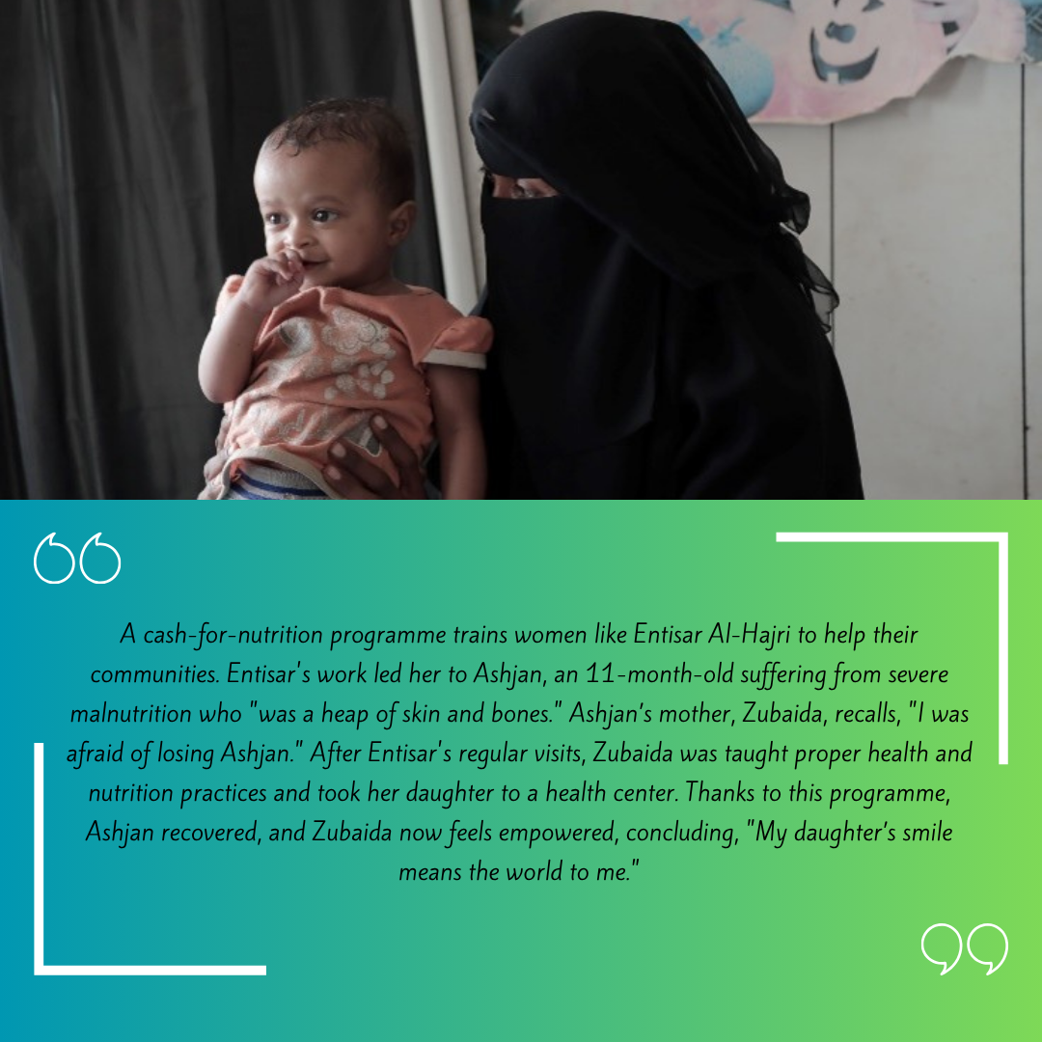
Photo credit: UNDP Yemen

Subcomponent 2.2 Cash for Work (CFW)
Workers setting up the foundation of water tank tower as a part of the geo-bundling interventions in Al-Majhafa, Lahj. | Photo Credit: @UNDP Yemen / 2024
Under the CFW subcomponent, the ESPECRP project has made significant contributions toward supporting vulnerable populations in conflict-affected areas of Yemen. By combining short-term income opportunities with the development of essential community assets, the program has helped households cope with food insecurity, enhanced climate resilience, and restored critical local services. From project inception through June 2025, a total of 276 CFW subprojects were identified across 171 subdistricts in 117 districts spanning all 22 governorates, with an estimated cost of US$ 41 million, representing 98 percent of the total CFW allocation under the three project funds (PF, AF, AF2). Of these, 145 subprojects (US$ 20.3 million) have been completed, 103 (US$ 15.9 million) are under implementation, and 24 (US$ 4.1 million) are in preparatory stages. Only four subprojects were cancelled, all previously reported. The allocation initially designated for Sa’ada under AF2 (US$ 595,000), suspended due to security developments, was reallocated to climate-affected areas in line with project objectives.
The CFW subcomponent under the PF has been fully completed, while AF is at 78 percent progress, with completion expected by the end of 2025. Following the recent clearance of a large number of Environmental and Social Action Plans (ESAPs), AF2 implementation has picked up, with approximately half of its allocated budget now under execution.

All CFW interventions are informed by participatory planning processes. Communities, in collaboration with the SFD team, identified high-impact and context-appropriate interventions during the preparation of social and technical studies. This inclusive and localized approach ensured effective resource utilization and maximized community benefits. Implemented subprojects have responded to pressing community needs such as agricultural land rehabilitation, irrigation canal repair, rainwater harvesting, rural road construction, home gardens, and sanitation infrastructure.

 | Completed |  | Ongoing |  | Cancelled |  | In Preparation |  | Total Subprojects
Intervention Type | # | US$ | # | US$ | # | US$ | # | US$ | # | US$
CFW – Agriculture | 3 | $264,988 | 6 | $923,632 |  |  |  |  | 9 | $1,188,620
CFW - Diversified | 102 | $15,012,764 | 67 | $10,403,430 | 3 | $693,107 | 16 | $2,506,121 | 188 | $28,615,422
CFW – Roads | 39 | $4,878,185 | 29 | $4,454,551 | 1 | $198,000 | 8 | $1,499,596 | 77 | $11,030,332
CFW – WASH | 1 | $91,316 | 1 | $78,570 |  |  |  |  | 2 | $169,886
Grand Total | 145 | $20,247,253 | 103 | $15,860,183 | 4 | $891,107 | 24 | $4,005,717 | 276 | $41,004,260
Table 7: Status of CFW Subprojects as of 30 June 2025

To date, 56,151 direct workers (72.3 percent of the project target) have accessed short-term wage employment, enabling them to purchase essential items, such as food and medicine, while improving their households’ well-being. Women comprised 31.6 percent, youth 53.1 percent, and IDPs 10.9 percent of total CFW workers. The program designed CFW tasks that were accessible and meaningful for women, including home gardening, tree planting, water carrying for construction and participation in training and awareness sessions, allowing them to work flexibly and safely. Women received individual payment cards for direct and transparent compensation and played active roles in project planning and decision-making, including through subproject committees—strengthening their leadership and voice in community development. Additionally, around 995 Persons with Disabilities (PWD) (20 percent women) were engaged in CFW thus far, in activities including construction of latrines, painting, terraces rehabilitation, life skills training, and awareness sessions, among others.

In addition to income support, CFW contributed to both skills’ development and longer-term economic resilience. Over 5,672 unskilled and semi-skilled workers received on-the-job training in areas such as masonry, stone cutting, cement work, plumbing, blacksmithing, and asset maintenance. These skills not only supported the delivery of high-quality community assets but also improved participants’ future employment beyond the project’s duration. The program also encouraged 1,806 families to acquire productive assets—including livestock, beehives, sewing machines, and small machinery—to support livelihood diversification and income generation. The table below provides disaggregated CFW workers per governorate.
Table 8: CFW Disaggregated Workers and Workdays per Governorate as 30 June 2025
GOVERNORATE | No. of SUBPROJECTS | NO. OF WORKERS |  |  |  | NO. OF WORKDAYS
GOVERNORATE | No. of SUBPROJECTS | TOTAL | WOMEN | IDPS/RETURNEES | YOUTH | NO. OF WORKDAYS
Abyan | 9 | 1,311 | 287 | 27 | 568 | 60,802
Aden | 4 | 625 | 168 | 173 | 368 | 14,585
Al-Bayda | 10 | 1,904 | 765 | 42 | 1,165 | 54,271
Al-Dhalea | 14 | 2,165 | 479 | 266 | 1,085 | 74,242
Al-Jawf | 7 | 1,548 | 313 | 151 | 807 | 62,472
Al-Mahrah | 3 | 604 | 258 | 103 | 370 | 34,149
AL-Mahwit | 9 | 1,523 | 164 | 107 | 786 | 60,145
Amran | 15 | 2,281 | 163 | 35 | 1,224 | 97,576
Dhamar | 16 | 4,039 | 1,482 | 18 | 2,285 | 130,167
Hadhramout | 11 | 2,123 | 326 | 8 | 978 | 90,158
Hajjah | 25 | 7,375 | 2,766 | 1,332 | 4,114 | 203,914
Al-Hudaydah | 29 | 7,686 | 3,688 | 118 | 3,966 | 277,129
Ibb | 25 | 5,413 | 2,530 | 459 | 2,881 | 182,662
Lahj | 9 | 1,583 | 213 | 24 | 730 | 61,715
Marib | 13 | 2,105 | 687 | 824 | 1,201 | 75,072
Raymah | 10 | 1,618 | 386 | 56 | 699 | 67,118
Sa’adah | 11 | 1,800 | 176 | 284 | 885 | 78,664
Sana’a | 12 | 2,430 | 242 | 331 | 1,328 | 75,167
Sana’a Capital | 5 | 1,119 | 150 | 445 | 762 | 23,640
Shabwah | 7 | 1,964 | 508 | 63 | 1,178 | 54,780
Socotra | 4 | 382 | 57 | - | 164 | 33,542
Taiz | 28 | 4,553 | 1,954 | 1,271 | 2,280 | 141,187
TOTAL | 276 | 56,151 | 17,762 | 6,137 | 29,824 | 1,953,157

The dual benefit of income and asset creation is evident in the tangible results. The project constructed 33,807 cubic meters of rainwater harvesting systems (73.4 percent of target), reducing water scarcity and easing the burden on women and children. Around 3,949 hectares of agricultural land and terraces (159.4 percent) were rehabilitated and irrigated, boosting food production and strengthening climate resilience. A total of 249 kilometers of rural feeder roads (119.4 percent) were paved, improving mobility, market access, and service delivery in previously isolated communities.

CFW also supported improved nutrition, health and shelter. 1,670 home vegetable gardens were established, increasing household food diversity and consumption of fresh produce. 7,131 latrines with cesspits improved sanitation coverage and reduced disease risks. To protect vulnerable families from climate shocks, 314 transitional shelters and 307 flood-resilient houses were constructed. Collectively, the completed CFW subprojects improved access to critical services for an estimated 454,837 people (67.2 percent of the target), approximately half of whom are women.

To promote sustained self-reliance, particularly among women, 1,700 households were supported in acquiring locally appropriate productive assets—ranging from livestock and beehives to sewing machines and motorcycles. In tandem, beneficiaries received life skills and entrepreneurship training that enabled them to produce and market items such as incense, perfumes, dairy products, pickles, and handicrafts—laying the groundwork for sustainable income-generation and long-term economic empowerment.

Table 9: CFW HH, Workers, and workdays per sector and category as of 30 June 2025
Intervention | # | NO. OF HH | NO. OF WORKERS |  |  |  | NO. OF WORKDAYS
Intervention | # | NO. OF HH | TOTAL | Women | IDP | YOUTH | TOTAL | Women | IDP | YOUTH
Agriculture | 9 | 1’800 | 2,695 | 34% | 1% | 51% | 77,529 | 34% | 2% | 49%
Diversified | 188 | 31,956 | 43,575 | 28% | 11% | 52% | 1,580,965 | 28% | 10% | 49%
Roads | 77 | 9,320 | 9,541 | 4% | 15% | 59% | 277,460 | 4% | 12% | 56%
WASH | 2 | 271 | 340 | 10% | 2% | 47% | 17,203 | 10% | 4% | 49%
TOTAL | 276 | 43,347 | 56,151 | 25% | 11% | 53% | 1,953,157 | 25% | 10% | 50%

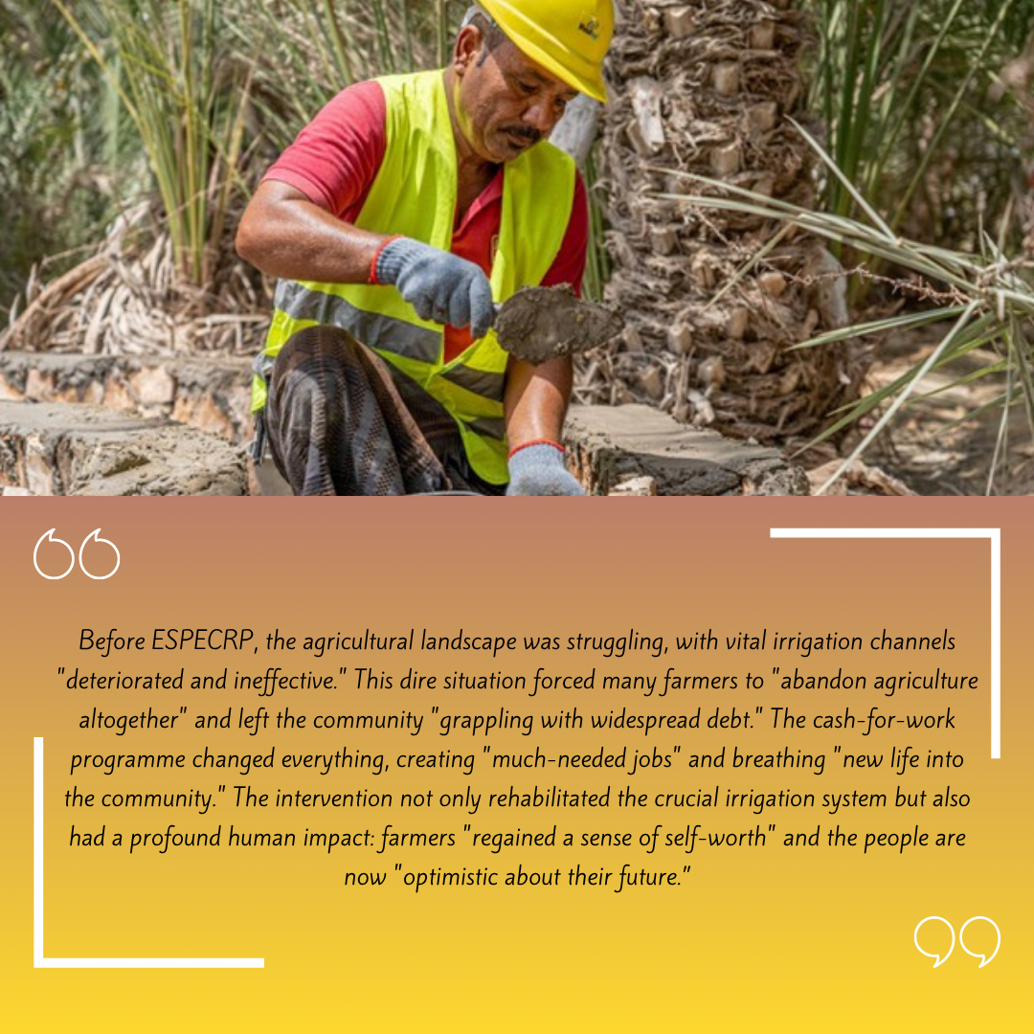
The implementation of the CFW subcomponent had previously faced delays due to the protracted process of preparing and obtaining clearances for Environmental and Social Action Plans (ESAPs). This challenge has been largely addressed, with a significant number of subprojects now cleared through increased support from the World Bank’s safeguards team.
Maintaining this momentum will be key to accelerating progress and enhancing complementarity across project subcomponents. Additional delays in some areas were caused by permit-related delays from local authorities, and occasional security or contextual issues, which the SFD has actively mitigated through escalated coordination and conflict-sensitive engagement with stakeholders.
Photo credit: UNDP Yemen

Subcomponent 2.3 Community Assets (CA)

Since its inception, the PWP subcomponent has achieved tangible results in improving access to essential services and enhancing the resilience of vulnerable and food-insecure communities. By the end of June 2025, a total of 384 subprojects had been approved across 226 subdistricts in 146 districts, covering all 22 governorates of Yemen, with an estimated total cost of US$ 36.2 million, representing 87 percent of the overall civil works allocation. Of these, 229 subprojects (US$ 18.6 million) were completed, 61 (US$ 7 million) are under implementation, 24 (US$ 2.9 million) are at contract signing stage, 22 (US$ 2 million) are under tendering, and 48 subprojects (US$ 5.5 million) are finalizing technical and safeguard assessments.

These community-prioritized interventions have addressed critical development needs including the construction of communal rainwater harvesting reservoirs, rehabilitation of water supply and sanitation networks, paving of rural roads, and protection of agricultural lands resulting in improved living conditions, food security, and climate adaptation in conflict-affected areas.

Table 10: Status of Subprojects under Subcomponent 2.2 (PWP) as of 30 June 2025
Subprojects | In Preparation |  | Under implementation |  | Completed |  | TOTAL
Sector of Intervention | No. | US$ | No. | US$ | No. | US$ | No. | US$
Agri Land Protection & irrigation | 40 | 4,225,000 | 11 | 1,346,320 | 78 | 6,396,915 | 129 | 11,968,235
Rainwater Harvesting | 27 | 2,880,000 | 20 | 1,742,552 | 34 | 2,837,393 | 81 | 7,459,945
Stone Paving Rural Roads |  |  | 1 | 40,536 | 6 | 336,832 | 7 | 377,368
Water Supply Schemes | 23 | 3,098,000 | 24 | 3,197,420 | 73 | 5,964,707 | 120 | 12,260,127
Sanitation | 4 | 400,000 | 5 | 692,496 | 38 | 3,074,581 | 47 | 4,167,077
Total | 94 | 10,603,000 | 61 | 7,019,324 | 229 | 18,610,428 | 384 | 36,232,752

A total of 89 subprojects (23 PF, 43 AF, 23 AF2) were implemented using the Community Contracting (CC) modality, valued at US$ 8.8 million, covering 45 agricultural land protection and irrigation, 38 rural road pavements, and 6 water schemes. To date, 34 CC subprojects have been completed, 16 are under implementation, and 39 in technical preparation. The CC approach not only accelerated delivery and enhanced local ownership but also built long-term community capacity. Several trained committee members advanced to skilled contractors, and two women successfully led construction contracts, including a water tank in Taiz and a canal in Dhamar, underscoring the project’s role in empowering women and strengthening local leadership.
a rugged, steep road was paved through PWP’s community contracting in Al-Sarrah, Al-Odein, Ibb. | Photo Credit: @UNDP Yemen / 2023

Table 11: Status of Community Contracting Subprojects (PWP) as of 30 June 2025
Subprojects | In Preparation |  | Under implementation |  | Completed |  | TOTAL
Sector of Intervention | No. | US$ | No. | US$ | No. | US$ | No. | US$
Agri Land Protection & irrigation | 28 | 3,025,000 | 4 | 520,326 | 13 | 876,321 | 45 | 4,421,647
Rainwater Harvesting | 2 | 250,000 | 3 | 301,913 |  |  | 5 | 551,913
Stone Paving Rural Roads | 8 | 1,210,000 | 9 | 1,384,299 | 21 | 1,150,988 | 38 | 374,5287.01
Water Supply Schemes | 1 | 80,000 |  |  |  |  | 1 | 80,000
Sanitation
Total | 39 | 4,565,000 | 16 | 2,206,538 | 34 | 2,027,309 | 89 | 8,798,847

To date, the subcomponent has provided short-term employment to 23,876 direct workers (45.9 percent of the target), including 649 women (30 percent of the women’s target), and 3,325 IDPs (13.9 percent), generating over 518,754 workdays and indirectly benefiting 166,600 household members. These job opportunities provided immediate income relief, while supporting longer-term recovery and resilience.

Table 12: CA Disaggregated Workers and Workdays per Governorate
GOVERNORATE | No. of SUBPROJECTS | NO. OF WORKERS |  |  | NO. OF WORKDAYS
GOVERNORATE | No. of SUBPROJECTS | TOTAL | WOMEN | IDPS/RETURNEES | NO. OF WORKDAYS
Abyan | 12 | 596 | - | 42 | 14,621
Aden | 9 | 519 | 6 | 210 | 15,252
Al Baidha | 12 | 662 | 16 | 112 | 17,485
Ad-Dhale’e | 14 | 586 | 14 | 59 | 10,494
Al-Jawf | 23 | 1,878 | 13 | 31 | 38,716
Al Mahrah | 16 | 929 | 6 | 208 | 15,933
Al Mahweet | 9 | 639 | 5 | 58 | 14,222
Amran | 12 | 632 | 10 | 45 | 11,102
Dhamar | 15 | 1,392 | 3 | 258 | 25,539
Hadhramout | 20 | 1,659 | 59 | 74 | 38,297
Hajjah | 16 | 470 | 2 | 74 | 10,893
Hodeidah | 26 | 1,886 | 18 | 260 | 51,829
Ibb | 26 | 1,524 | 86 | 104 | 33,473
Lahj | 14 | 571 | 3 | 11 | 12,630
Marib | 23 | 1,299 | 9 | 527 | 34,467
Raymah | 11 | 979 | 8 | 108 | 20,764
Sa’adah | 24 | 1,601 | 40 | 503 | 32,068
Sana’a | 17 | 479 | 48 | 109 | 12,539
Sana’a Capital | 15 | 1,423 | 72 | 130 | 30,690
Shabwah | 22 | 1,244 | 89 | 96 | 16,066
Socotra | 12 | 585 | 17 | 30 | 9,146
Taiz | 36 | 2,257 | 125 | 276 | 52,473
TOTAL | 384 | 23,810 | 649 | 3325 | 518,699
The infrastructure delivered under the subcomponent has directly enhanced access to essential services and contributed to climate resilience. To date, 78,287 cubic meters of rainwater harvesting capacity (53.1 percent of target) have been constructed, ensuring safer and more reliable access to clean water.
Additionally, 137,988 meters of water supply and 1,689 meters of sanitation networks have been repaired, with four new public latrines constructed—reducing waterborne disease risks and strengthening sustainable water use for both domestic and agricultural purposes.
The subcomponent has also advanced climate-resilient food production and disaster mitigation, rehabilitating and protecting 3,586 hectares of agricultural land (71.6 percent of the target), while the improvement of 69 kilometers of rural roads (42.6 percent) significantly reduced transport costs and isolation in remote areas. Associated retaining walls and tree planting further helped prevent landslides and soil erosion.
The combination of physical infrastructure and community awareness on climate change enhanced co-benefits and sustainability. Overall, completed subprojects have improved access to key services for 715,226 people, exceeding the overall target by 6.7 percent, with an equitable reach across gender.

Table 13: Total Job Opportunities under CA as of 30 June 2025
Sector | Workdays generated |  |  | Direct Beneficiaries of wages
Sector | Total | % Host Community | % IDP's | Total | % Host Community | % IDP's
Water harvesting tanks | 63,191 | 55% | 15% | 3,537 | 47% | 12%
Land Protection & Irrigation | 17,5587 | 46% | 16% | 8,029 | 45% | 19%
Rural roads pavement | 201,752.5 | 60% | 11% | 8,912 | 58% | 9%
Sanitation & Water supply | 78,168 | 50% | 13% | 3,332 | 47% | 17%
Total | 518,698.5 | 53% | 13% | 23,810 | 50% | 14%

The sanctions on Yemen Kuwait Bank (YKB), which held PWP’s AF account with US$ 2.3 million, caused significant delays in contractor payments and disrupted implementation. A temporary solution (weekly disbursements of US$ 100,000) helped reduce the stuck amount to around US$ 1 million, enabling PWP to request new advances and resume payments and delivery.
UNDP continues to liaise with the U.S. Treasury to release the remaining funds. Delays in preparing and clearing Environmental and Social (E&S) documents also hindered progress, though recent approvals have improved momentum.
Sustaining project assets requires tailored community training for Operation and Maintenance (O&M), which should be factored into future financing. Despite awareness efforts and inclusive hiring, women’s participation remains low; PWP and UNDP are exploring additional strategies, including leveraging the geobundling approach to reach women unable to work in civil tasks.
Additionally, the aging PWP vehicle fleet poses safety risks and high maintenance costs. UNDP and the World Bank are reviewing the option of procuring new vehicles, with a final decision expected in next reporting period.
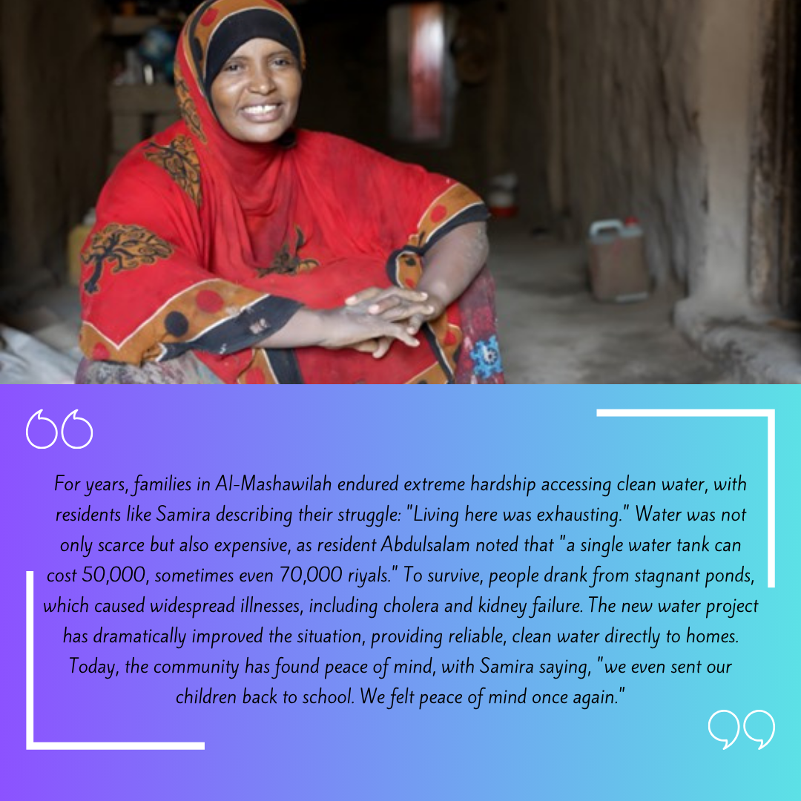
Photo credit: UNDP Yemen

Subcomponent 2.4: Economic Opportunities and Food Market Resilience

Subcomponent 2.4a Increased Access to finance for MSMEs

Yemen Loan Guarantee program (YLG):
Through the implementation of the Portfolio Guarantee Model (PGM), ESPECRP – via the Yemen Loan Guarantee (YLG) – significantly enhanced MSMEs' access to finance by mitigating credit risks for financial institutions and MFIs. Contracts were signed with all six targeted MFIs, resulting in guaranteed loans to 5,182 MSMEs (138 percent of target), creating or sustaining around 8,286 jobs across diverse productive sectors. Notably, 44.4 percent of supported businesses were in rural areas, 19.3 percent in the South, with 50.8 percent youth-led and 18.8 percent women-led. The percentage of women has improved significantly under AF2 since the WB’s approval of opening the sectors to all women-led businesses rather than food sectors. The participation is expected to increase even more should the risk coverage increase from 70 percent to 90 percent for women-led businesses. The total value of guaranteed loans reached US$ 13.8 million, demonstrating tangible progress in promoting inclusive economic recovery and livelihood.

Table 14: Number of guarantees issued and sum of guaranteed amount as of 30 June 2025
Key indicator | Alamal MF | Azal MF | Alitihad MF | Alkuraimi MF | Althadhamon | Nama MF | Total
# of Guarantees | 89 | 1919 | 359 | 2,346 | 270 | 199 | 5,182
Around 44.4 percent of the supported MSMEs were in rural areas, and around 19.3 percent of them were in the South. Furthermore, 50.8 percent of the MSMEs were youth-led and 18.8 percent were women-led. The supported MSMEs included a variety of productive and economic sectors and different purposes as in the following table:
Table 15: Cumulative number of clients by sector and by loan purpose, as of 30 June 2025
Sector | Number of Clients | % | Loan Purpose | Number of Clients | %
Agricultural | 1,364 | 26.32% | Assets for Business | 562 | 10.85%
Livestock | 812 | 15.67% | Inventory | 2,551 | 49.23%
Commercial | 2,530 | 48.82% | Green Houses | 72 | 1.39%
Fish | 34 | 0.66% | Solar Energy | 175 | 3.38%
Industry | 197 | 3.80% | Fuel for Energy | 249 | 4.81%
Service | 245 | 4.73% | Raw Materials | 828 | 15.98%
 |  |  | Livestock | 745 | 14.38%
Total | 5,182 |  | Total | 5,182

A key challenge for YLG was the difficulty they faced to access their balance (US$ 1.07 million) held at YKB due to U.S. sanctions. However, over half of the funds have been successfully withdrawn under a rescheduled arrangement, enabling continued program delivery.
Village Saving and Loan Associations (VSLAs):
VSLAs continued to prove to be a powerful driver of economic inclusion and resilience in rural Yemen. Key lessons from the VSLAs show that they strengthen financial habits, improve access to credit, and enhance financial literacy, enabling members to build sustainable livelihoods. They also promote community solidarity, leadership, and personal confidence, empowering individuals, especially women, to actively participate in economic and social development.
Cumulatively, by the end of June 2025, the project formed 690 VSLAs (96.5 percent of the total target) of which 49.7 percent are women VSLAs. Through community mobilization and capacity-building initiatives, the project has equipped 16,814 VSLA members (of whom 8,371 are women) with VSLA-related materials, including cash boxes and stationery, as well as with training in savings, lending, financial literacy and entrepreneurship. To enhance financial skills and ensure effective record-keeping of the VSLAs, 7,981 (52 percent women) of the VSLA members received a five-day training on financial accounting.
In addition, the project provided 3,350 (1,923 women members, 57 percent) with vocational skills training. All these efforts have strengthened members’ ability to manage their finances, operate SMEs effectively, and improve their livelihoods. Cumulatively, 1,438 loans (of which 54 percent for women) have been issued and the saving totaled to around amounting to YER 544.2 million (US$ 1.03 million equivalent), supporting diverse economic activities and creating or sustaining 2,876 job opportunities.

Table 16: Loans Disbursed by VSLAs
Business Type/ Sector | N. of loans disbursed |  |  | %
Business Type/ Sector | Men | Women | Total | %
Beekeeping, Livestock, and Agricultural | 278 | 308 | 586 | 41
Commercial | 166 | 248 | 414 | 29
Handcraft/Industry | 31 | 218 | 249 | 17
Service | 139 | 50 | 189 | 13
Total | 614 | 824 | 1,438 | 100%

Beyond economic gains, VSLAs fostered financial independence, confidence, and collective voice, especially for women, enabling them to shape household and community decisions. Yet, VSLAs face three main challenges: limited internal funds, which restrict members from scaling or starting businesses; low literacy levels, especially among women, which hinder effective financial management; and limited access to vocational training.
Addressing these requires linking VSLAs with MFIs for additional funding, providing tailored literacy programs, and expanding vocational training to empower more members with practical business skills.

Sub-component 2.4b Direct support to MSMEs and Business Associations in Critical Sectors
one of SMEPS’ consultants explains to some women livestock breeders proper ways to feed their livestock. | Photo Credit: @UNDP Yemen / 2022

During the reporting period, the MSME subcomponent of ESPECRP, implemented by SMEPS, continued to deliver tangible impacts on household food security, job creation, and private sector revitalization in fragile and conflict-affected areas. By supporting micro, small, and medium enterprises (MSMEs), micro-producers, and cooperatives, the project has helped sustain critical production activities, promote inclusive economic participation, and strengthen local value chains.
As of 30 June 2025, a total of 2,839 MSMEs (24.3 percent of which are women-led) have received financial and technical assistance across 14 governorates, reaching 76.7 percent of the target set under the combined PF, AF, and AF2 grants. The interventions span a diverse range of livelihoods, including 1,074 farmers, 469 livestock breeders, 250 fisher people, 707 supply chain enablers, 216 entrepreneurs, and 56 midwife-led rural clinics, enhancing productivity and service provision in underserved areas. These interventions have directly contributed to the creation of 18,226 jobs, 14 percent of which are held by women, and indirectly benefitted thousands more through improved access to goods and services.
The project has also strengthened 34 food cooperatives and 33 business associations through asset transfers, institutional capacity building, and operational training, boosting their ability to aggregate production, manage risks, and scale market access. This has improved coordination across the food value chain and increased resilience to shocks. Support to the Yemen Private Sector Cluster (YPSC) contributed to unifying fragmented private sector voices through organizational capacity assessments, targeted training, and strategic studies (e.g., on e-money systems and private sector roles in recovery), further positioning the private sector as a key factor in Yemen’s economic recovery.
The project’s adoption of climate-smart practices—including solar energy systems, drip irrigation, and sustainable agricultural techniques—has led to measurable environmental and productivity gains. These practices have helped reduce CO₂ emissions, conserve scarce water resources, and expand food production capacity, demonstrating the project's alignment with climate adaptation and sustainability objectives. The project's flexible, pilot-based design enabled the successful adaptation of SMEPS’ value chain approach, now being scaled up through World Bank and other donor-funded initiatives. Lessons indicate that targeting interventions at the governorate level, particularly in sectors like midwifery, improves relevance and outreach. Similarly, early climate assessments informed seasonal crop selection, enabling farmers to diversify production and better withstand climate-related disruptions. Engaging university students through entrepreneurship workshops and graduation projects also proved effective in reaching the youth segment and fostering innovation.
Despite strong progress, several challenges impacted implementation during the biannual reporting period. Delays in local procurement—largely due to dependence on imported goods—were addressed through supplier orientation and localized capacity building across main cities. In the North, prolonged security clearance and permit processes slowed operations; however, the team maintained close engagement with authorities to navigate these bottlenecks. Financial constraints, such as liquidity shortages and banking limitations, were mitigated through alternative transfer arrangements with different banks to ensure payment continuity.
Documenting field interventions, especially in areas like Otmah (Dhamar), was hampered by security restrictions on professional filming, prompting the use of mobile-based documentation tools to capture and share success stories. In Aden and Hadhramaut, difficulties in reaching youth entrepreneurs and innovators led to increased outreach via thematic workshops in partnership with universities, targeting sectors such as IT, healthcare, and agribusiness.
Lastly, the high capital threshold required for business registration (around US$ 18,800 equivalent) emerged as a key barrier for early-stage entrepreneurs in several governorates. In response, the team facilitated the adoption of a low-cost licensing model from Sana’a’s Ministry of Trade and Industry, which enabled broader inclusion at a fraction of the cost (below US$ 50 equivalent), fostering a more enabling environment for small-scale startups.

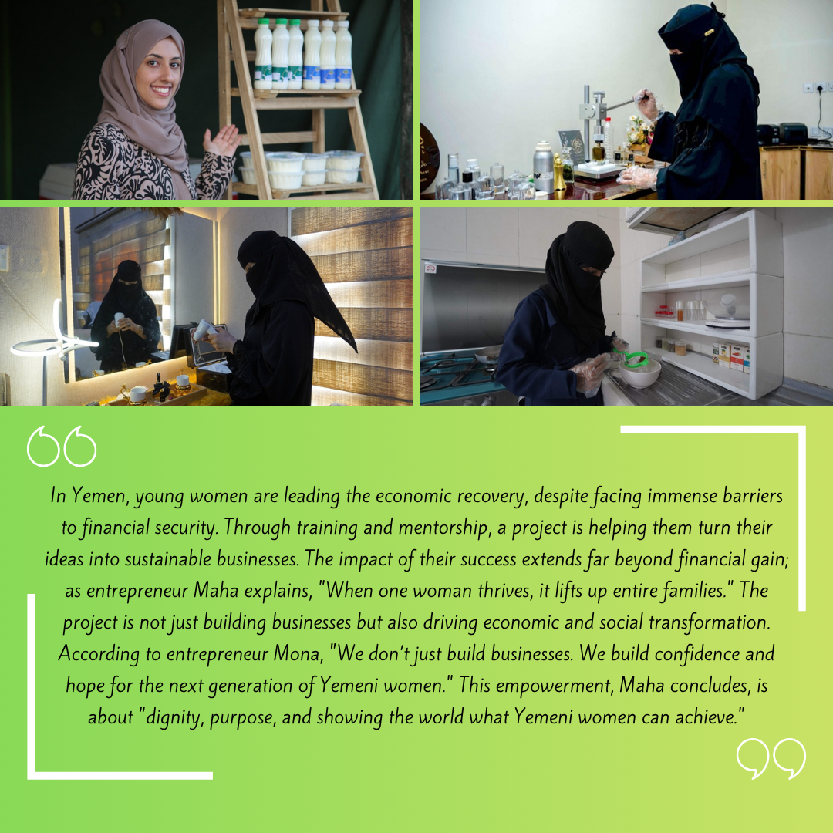
Photo credit: UNDP Yemen

Component 2 Project Management, Monitoring, Evaluation and Capacity Building of National Institutions

Project Management Unit (PMU): The project management unit remains fully staffed and the UNDP Country Office continues to provide oversight and other support required for the project.

ESPECRP Procurement Plan: (the procurement plan was updated in this link): Procurement implementation under ESPECRP progressed well during the reporting period, supported by the initiation and continuation of a significant number of subprojects and associated contracts. The contract with the International Food Policy Research Institute (IFPRI) for the impact evaluation of the geobundling approach was formally activated. IFPRI has since subcontracted a national firm for data collection and completed training for enumerators, with fieldwork expected to commence shortly. Additionally, the procurement process for the Third-Party Monitoring Agency (TPMA) was finalized, and the selected agency is scheduled to begin operations in the last quarter of 2025.
Adjustments were made to the procurement plans to reflect evolving contextual challenges. These included delays related to the re-designation of the Houthis as a Foreign Terrorist Organization (FTO), which affected banking operations and cash flow, as well as delayed permits from local authorities in Houthi-controlled areas. The lengthy clearance processes for environmental and social safeguards and localized security developments also contributed to procurement delays. Furthermore, escalating security tensions continued to disrupt supply chains, increase transport and logistics costs, and hinder access to certain governorates.
Procurement in some technical areas remained constrained by a limited pool of qualified suppliers, particularly for specialized consultancy services. To mitigate these issues, UNDP and IPs have adopted adaptive procurement strategies, including revising payment modalities, improving coordination with authorities, and maintaining cross-agency collaboration and close engagement with vendors and logistics providers.
During the reporting period, 15 procurement-related complaints were formally recorded—two from SFD, nine from PWP and four from SMEPS. Most grievances concerned delayed payments resulting from banking sanctions on Yemen Kuwait Bank (YKB) and challenges linked to exchange rate volatility. In response, IPs provided timely clarifications, scheduled payments under an agreed release arrangement with YKB, and implemented compensation mechanisms for currency fluctuations while issuing new contracts in U.S. dollars.
For complaints related to delayed contract awards or evaluation results, IPs reviewed procurement processes and communicated outcomes transparently. All recorded complaints were resolved and closed. The proactive use of grievance redress mechanisms and regular follow-ups contributed to timely resolution, enhanced accountability, and reduced local tensions.

The Geobundling Approach (GB):
SFD, PWP, and SMEPS in Aden meet to discuss the implementation plan for Al-Majhaf, Lahj, geo-bundling | Photo Credit: @UNDP Yemen / 2024

The geobundling approach under ESPECRP continues to demonstrate strong potential in catalyzing inclusive, community-led development in Yemen. Implementation is advancing across 87 out of 128 targeted sub-districts, selected for their high levels of food insecurity and malnutrition and considering agricultural potentials, accessibility and geographic balance. All 67 subdistricts under the Additional Financing (AF) are actively implementing subprojects, while 20 of the 51 AF2 subdistricts have commenced implementation. The remaining 20 are scheduled to begin in the next reporting period, while 11 subdistricts have been deferred as randomized control areas for the upcoming impact evaluation.
At the heart of geobundling lies the Tamkeen community mobilization program, which has empowered communities to lead their own development processes. Through this, the project has established 1,318 Village Cooperation Councils (VCCs), with nearly equal participation of men (6,939) and women (6,796). These councils were formed through transparent, community-led elections facilitated by 1,566 trained local young community mobilizers (including 763 women) who guided VCCs in participatory needs assessments and village development planning, and who also encouraged inclusion of vulnerable groups and facilitated engagement of local authorities. Building on these efforts, 119 Sub-District Development Committees (SDDCs), comprising 1,303 women and 1,419 men elected from the VCCs, were established and trained in resilience planning and needs prioritization as well as liaison with local authorities. As a result, 119 Subdistrict Needs Plans (SDNPs) were prepared and co-endorsed with local authorities. Based on these locally developed plans, ESPECRP has developed 97 geobundling implementation plans aligned with project objectives based on effective coordination and field verification by the IPs.
Geobundling has notably enhanced coordination among implementing partners, not only in the joint identification of local priorities, but also in promoting synergy, increasing implementation efficiency, and enabling collective risk management. Compared to single-intervention models, geobundled subdistricts – particularly those with well-sequenced, diverse interventions – have seen stronger and more layered impacts. As a result, geobundled areas have benefited from: higher wage employment and skills development for youth and vulnerable groups; expanded community assets and improved access to more social services; increased cash flow in local economies and a revival of local supply chains; and boosted support for SMEs and income-generating activities, especially for women and youth, through VSLA schemes and value chain support. However, the degree of impact varies across communities depending on the scale and sequencing of interventions and the strength of local coordination. Lessons from implementation underscore the importance of defining complementarities and sequencing during the design phase and actively facilitating interventions during rollout to fully realize the potential of geobundling.
The geobundling approach has demonstrated strong potential in promoting inclusive governance and a bottom-up, data-driven development process that addresses the real needs of vulnerable populations and fosters greater accountability. Importantly, the approach has fostered significant social norm shifts in support of women's leadership and participation. By design, 50 percent of VCC seats are allocated to women, and separate, facilitated consultations have enabled women to influence village planning processes. These mechanisms have increased community acceptance of women's active engagement in governance, joint self-help initiatives, and the use of services such as education, maternal health, and life-skills training. Furthermore, the approach has equipped local youth with strong community mobilization and local development skills, empowering them to guide their communities and local authorities for inclusive resilience and development.
More than 1,500 self-help initiatives have been launched in target subdistricts, showcasing communities’ ability to mobilize local resources and implement essential projects such as roads, water systems, and education facilities. Geobundling has fostered social cohesion by promoting shared goals, joint planning, and transparent resource use. Communities, including marginalized groups such as the Muhamasheen, are actively engaged in planning and decision-making. VCCs have also proven critical during crises—mobilizing support for displaced persons, managing localized health outbreaks, and facilitating aid distribution. These efforts have translated into stronger social capital, inclusive representation, and a growing culture of ownership and accountability at the grassroots level—positioning communities to play a pivotal role in future recovery and reconstruction.
While the geobundling model has demonstrated promising results, several operational and structural challenges require attention:
- Capacity Gaps: Field teams require enhanced training in coordination, communication, and outcome-based reporting. Continued investment in capacity building for VCCs, SDDCs, local authorities, and consultants is essential.
- Design Flexibility and Financing Gaps: Greater adaptability in targeting criteria, resource reallocation, and clearance processes is needed to accommodate community realities. Certain critical sectors (e.g., health, education, and infrastructure) remain underfunded or excluded. Enhanced advocacy is needed to attract additional donors to expand the GB approach.
- Climate Adaptation and Gender Sensitivity: To ensure long-term resilience, interventions should be proactively designed to contribute to climate co-benefits and tailored to address social norms and constraints faced by women and vulnerable groups.
TPM Summary on Geobundling: TPM confirms GB’s potential to bridge the humanitarian development divide, with early synergies observed in 15 southern GB sites. Beneficiaries engaged in multiple interventions (CFN, CFW, VSLAs) reported improved food security, higher household incomes, and stronger community engagement—e.g., VSLA members in agriculture often moved into higher income brackets. However, awareness and integrated participation remain limited, feedback channels are weak, and data gaps constrain robust measurement. Still, over 75 percent of respondents noted positive economic/social change and 91 percent confirmed needs were at least moderately met. TPM calls for improved communication, stronger monitoring and feedback, more integrated sector planning, and visible community-led ownership.
MIS for GB Tracking: To strengthen planning, monitoring, and coordination, UNDP’s MIS—launched in late 2024—was enhanced in early 2025 with a full Web Application Penetration Test to address vulnerabilities. Developed with UNICC, the secure platform now supports full-scale rollout, integrating user feedback to optimize project tracking and decision-making. A dedicated GB MIS with interactive maps and real-time dashboards enables partners to visualize coverage, align interventions, and prioritize based on needs. This system improves accountability, supports impact evaluation with spatial analysis, and ensures GB programming remains data-driven and responsive. To access the developed products along with Geobundling’s MIS, please refer to the provided links: (a) Yemen Portal; (b) Geo-bundling Dashboard: (c) GPTA: Data Collection App; (d) SharePoint eDocument site ; (e) Power BI Interactive Report.

Institutional Capacity Building (ICB):
ESPECRP has been making steady progress in strengthening the institutional and operational capacities of the IPs across multiple areas of engagement. To date, specific capacity activities included IPSAS and fraud prevention courses for accounting staff, IPDET training for M&E officers, gender and OHS-focused ToTs, and the development of social media and digital context strategies across all IPs (SFD, PWP and SMEPs). In addition, the project has strengthened GeoEnabling Monitoring (GEMS) as well as Safeguards capacity through the World Bank’s ESF-focused training modules delivered in Cairo in late 2022 and virtually in May 2025, addressing conflict sensitivity, lands acquisition, resettlement, and Prevention of Sexual Harassment and Exploitation (PSEA). At the institutional level, SFD’s capacity has been further supported on several operational areas, including financial management, procurement, value for money, communications, climate change, and internal monitoring tools, including the in-house development of TPM tracking systems. PWP, in turn, benefited from the project’s support on the creation of an integrated information management system tailored to its operational needs in addition to WB supported capacity development through UNOPS including the updating of manuals and staff trainings.
The WB also facilitated a wide range of knowledge exchanges and South-South learning engagements under the Yemen Multi-Donor Trust Fund (MDTF), which have significantly enriched institutional learning and peer engagement. These exchanges covered thematic areas such as climate resilience, social protection, and value chain development, and were held with institutions like FinEquity, CGAP, UNICEF, and peer countries including India, Laos, Peru, Rwanda, Kyrgyz Republic, Pakistan, and Egypt. Recent highlights include the South-South Learning Forum (SSLF) held in Kigali in February 2025, a joint knowledge exchange with the Kyrgyz Republic, and a study tour on gender and economic inclusion in Cairo in June 2025. SFD also took part in the IMF Social Protection training in Kuwait and the Core Social Protection course in Rome to deepen understanding of adaptive safety nets. In parallel, several virtual Cash-for-Nutrition (CFN) learning events were conducted, focusing on integrating productive inclusion and lessons from international experiences.
Looking ahead, the project plans to implement climate-smart training programs across all IPs to enhance tracking and mainstreaming of climate co-benefits. SFD’s future capacity development priorities include e-procurement, comprehensive risk management, cybersecurity, and HR systems, while SMEPS is preparing to update its HR manuals and deliver targeted trainings in data science, digital procurement, strategic communication, and results-based evaluation. PWP also has plans to enhance risk management and other capacity areas. These cumulative investments reflect ESPECRP’s strategic commitment to institutionalizing adaptive delivery models, promoting innovation, and expanding local systems' ability to respond to food insecurity and malnutrition. A detailed breakdown of all ICB activities – including objectives, funding source, targeted participants, and completion status – is maintained in the updated Institutional Capacity Building tracking sheet, available at this link.

The Entry Criteria for Access (ECA), jointly agreed upon by UNDP and the WB, outlines essential conditions and risk mitigation measures required for project implementation under ESPECRP. Serving as a critical safeguard, the ECA ensures compliance with international standards on anti-money laundering, counter-terrorist financing, financial stability, gender inclusion, and operational integrity. It enables structured risk assessment, clear accountability through defined indicators and corrective actions, and reinforces the secure, inclusive, and transparent delivery of development and humanitarian interventions. The Project Operations Manual (POM) has been updated to include the ECA, and is available at this link.

Monitoring and Evaluation

UNDP Field Visits
UNDP team met with health educators and mothers in Sawakh, Hajjah, who benefited from the cash-for-nutrition programme and its services. | Photo Credit: @UNDP Yemen / 2024
Since inception through June 2025, UNDP conducted field visits to 98 subproject sites across 39 districts in 11 governorates, with a focus on implementation quality, community engagement, and compliance. Of these, 46 geobundled sites were closely monitored across Sa’ada, Amran, Hadramout, Ibb, Taiz, and Socotra. Evidence from interviews, Focus Group Discussions (FGD), and direct observation confirms that interventions—such as CFN, CFW and VSLAs—have tangibly improved food security, restored community assets, and advanced household resilience.
Geobundling has proven particularly impactful, driving strong cross-partner coordination (SFD, PWP, SMEPS) and enabling integrated delivery of nutrition, finance, and infrastructure support. Results include protection of over 600 hectares of farmland, doubled crop yields, and income growth through women-led VSLA enterprises. Participants also reported increased skills, social cohesion, and high satisfaction with health and nutrition services.
While challenges such as infrastructure vulnerabilities, logistical bottlenecks, and information gaps were noted, corrective measures are already informing scalable solutions. These include community-led stabilization works, enhanced outreach, and improved transport for health access. Continued technical refinement and partner alignment are critical to sustaining and expanding the program’s transformative impact. The field visits report can be found in this link.
Third Party Monitoring (TPM)
Since ESPECRP’s inception, the Third-Party Monitoring Agent (TPMA) has verified 417 subprojects across all components—CFN, CFW, Small Community Infrastructure, and SMEs—with balanced geographic coverage (56 percent North, 44 percent South). Using gender-sensitive methods, the TPMA conducted 10,608 interviews and 441 focus group discussions, engaging over 10,500 people, including direct and indirect beneficiaries and key informants. The findings consistently highlight strong, community-level impact on nutrition, livelihoods, and resilience, supported by compelling personal testimonies. In early 2025 alone, 124 subprojects were assessed through 3,125 interviews and 57 FGDs, confirming the continued relevance and reach of interventions. Overall, the monitoring affirms ESPECRP’s inclusive, community-led approach and its tangible contributions to improving lives in conflict-affected areas. Key subcomponent findings are summarized below, with full details in the TPMA reports.
Cash for Nutrition (CFN):
During the first half of 2025, over 95 percent of the interviewed 175 beneficiary mothers of malnourished children and 118 community health educators across Yemen reported satisfaction and significant improvements in child nutrition. Training was highly effective, with 96 percent of mothers reporting improved feeding practices and observable gains in their children’s weight, immunity, and vitality. Health educators, with a 92 percent satisfaction rate, played a critical role in identifying severe malnutrition cases and mentoring mothers. Over 96 percent of mothers observed positive changes in their children’s health. However, regional disparities remain unambiguous (child food poverty was 31 percent in the North versus 70 percent in the South), driven by inflation and gaps in breastfeeding practices. Conversely, Food Consumption Scores (FCS) were better in the South—93 percent of mothers had acceptable scores compared to 75 percent in the North (educators: North 74 percent, South 79 percent).
Cash for Work (CFW):
SFD continued its CFW program across Yemen, focusing on infrastructure improvements such as irrigation, agriculture, roads, and environmental subprojects. A total of 752 direct beneficiaries were interviewed, including 19 percent women, with 99 percent confirming strong alignment with local priorities and community involvement. Over 96 percent of 758 community members expressed satisfaction and noted positive impacts. While the initiative improved household well-being and showed strong gender inclusion—such as providing childcare for working mothers—food security varied, with 86 percent of women and 72 percent of men reporting acceptable food consumption scores. Most community members (93 percent) confirmed access to subproject assets, although maintenance planning remains inadequate. Key outcomes included better access to services (57 percent), increased economic opportunities (50 percent), and greater community pride (45 percent). Despite the program’s success, challenges persist in areas such as wage/workday equity, maintenance planning, complaint mechanisms (especially for women), childcare continuity, and skills development for female workers. Addressing these challenges will be critical for enhancing sustainability and resilience.
Community Assets (CA):
PWP advanced critical infrastructure efforts in Yemen through subprojects like land restoration, road and irrigation repairs, and water access improvements. Across 47 subprojects, 267 direct beneficiaries and 728 community members (including 270 women) were interviewed during the reporting period. However, female participation as wage workers remained very low due to the nature of the implemented interventions under PWP. Community engagement was strong, with 97 percent of beneficiaries confirming alignment with local priorities and 96 percent noting community involvement in beneficiary selection. Most workers were satisfied with project management and quality, though about 10 percent were dissatisfied with or unaware of complaint mechanisms. Wage payments were largely timely (92 percent), though southern areas reported more delays. A 25 percent wage gap remained between northern and southern workers, even after the adjustment for the cost of living. Despite earning less, northern households reported higher well-being gains (54 percent) than southern ones (30 percent), likely due to greater initial poverty. While PWP delivered quality infrastructure and economic support, further progress is needed in gender inclusion, maintenance planning, and skills development. Addressing local hiring equity and long-term asset sustainability will be key to ensuring resilience and inclusive, lasting community impact.
Village Savings and Loan Associations (VSLAs):
The Village Savings and Loan Associations (VSLAs), supported by SFD-SMED, have made strong progress in advancing financial inclusion, gender empowerment, and community solidarity during the first half of 2025. Interviews with 205 members (100 men, 105 women) across 10 subprojects revealed increased savings habits, effective training outcomes, and high satisfaction. VSLAs promoted savings even among the poorest members, with 96 percent confirming the affordability of minimum contributions. Savings levels varied by region and program maturity: northern members saved more (men: YER 49,100; women: YER 36,400) than southern members (men: YER 23,000; women: YER 29,000).
Training played a central role, especially for women, who received more support in financial literacy, entrepreneurship and life skills. Around 90 percent of female members benefited from these trainings. Loan access was moderate, with 43 percent of men and 50 percent of women receiving loans—primarily for productive uses. The VSLAs also fostered strong social benefits, as 90 percent of members reported improved family cohesion through shared financial goals. To maximize impact, the program should continue strengthening gender-inclusive practices and provide follow-up support after training to boost financial resilience and poverty reduction.
SMEPS Support for Farmer Households, Livestock Breeders, Value Chain Participants, and Business Associations:
SMEPS implemented interventions across multiple sectors—farmer households, livestock breeders, value chain participants, and business associations—in the northern and southern regions. The support included in-kind assistance, technical training, and capacity-building programs, with a focus on improving productivity, reducing costs, and expanding market access. While the interventions yielded high satisfaction rates among beneficiaries, disparities in financial support, accessibility, grievance awareness, and long-term sustainability were observed by the TPM agency.
Support to Farmer Households
Forty-one farmers (34 men, 7 women) received irrigation and fertilizer assistance, with drip irrigation training cited as the most beneficial. All farmers reported increased productivity, more diverse crops, and an average cost reduction of 44 percent. Additionally, 91 percent of farmers reported improved yields and higher income, with half employing extra workers, thus boosting local employment. Despite these gains, issues persisted—many farmers lacked awareness of SMEPS’ grievance system, and some felt the support only partially met their needs. Non-supported farmers struggled with the affordability of drip irrigation systems.
Support to Livestock Breeders
In the northern governorates, 20 female livestock breeders were interviewed who received fodder, vaccines, and cash transfers, leading to notable improvements. About 85 percent reported increased livestock productivity, with an average cost reduction of 46 percent, while 95 percent gained valuable skills in animal health and feeding. The program excelled in training quality and grievance awareness, with all breeders satisfied, well-supported, and fully informed about the feedback system. However, despite these successes, many felt the assistance only "partly" addressed their needs, indicating a need for expanded support to ensure long-term sustainability.
Support to Value Chain Participants
A total of 33 participants (29 male and 4 female) were interviewed who were engaged in agriculture, livestock, and diversified businesses across the last two quarters. The impact varied, with 84 percent reporting capital increases—averaging 59 percent in agriculture and 141 percent in livestock. Marketing improvements were also significant, with 90 percent gaining access to new markets. Businesses created jobs, hiring an average of two additional workers each. However, challenges persisted, including pricing difficulties and a lack of business management skills among 40 percent of participants.
Support to Business Associations
Nineteen representatives (12 male and 7 female) of the three supported business associations were interviewed, who received various support. Results were mixed. Two of the three associations increased capital and profits through cost reduction and quality improvements, while one hired 13 additional male workers. However, a significant number of interviewed association members reported challenges, with 44 percent expressing dissatisfaction due to delayed support. Furthermore, 88 percent faced barriers in market expansion, and no capital growth was reported during the last two quarters of 2025. These findings highlight the need for timely assistance and stronger strategies to overcome market challenges. Conversely, SMEPS interventions significantly boosted productivity, incomes, and employment across sectors, with high beneficiary satisfaction in training and in-kind support. However, gaps in grievance awareness, gender disparities, and sustainability challenges must be addressed to maximize long-term impact.

Social and Environmental Risk Management

Environmental and Social Framework (ESF) status
One of PWP’s engineers inspecting a construction site. | Photo Credit: @UNDP Yemen / 2024
UNDP has ensured full compliance with the Environmental and Social Commitment Plan (ESCP), having prepared and publicly disclosed all required environmental and social instruments—including those related to Additional Financing phases AF1 and AF2. Updated Environmental and Social Framework (ESF) tools are now accessible on the websites of UNDP and its implementing partners, reinforcing transparency and accountability. In the first half of 2025, UNDP further strengthened its safeguard framework by updating the project's Labor Management Plan and Stakeholder Engagement Plan. Additionally, a Road Safety Plan was developed and is currently under review by implementing partners, marking another step toward enhanced risk management and operational safety across project sites.
Environmental and Social Plans and Risk Assessments
In the first half of 2025, UNDP submitted 19 Environmental and Social Action Plans (ESAPs) for review, with 18 cleared by the WB and one under final review. This brings the total to 66 ESAPs, covering 246 subprojects under Additional Financing 1 and 2 (AF1 & AF2), with a combined value of US$ 32.7 million. For lower-risk subprojects, 13 Environmental and Social Risk Assessment and Clauses (ESRAACs) were submitted and fully cleared, raising the total to 47 ESRAACs covering 108 subprojects, valued at US$ 14.4 million. These efforts reflect strong adherence to environmental and social safeguard standards across the portfolio.

Table 17: Status of ESAPs and ESRAAC under ESPECRP cumulatively as of 30 June 2025
Category | IP | # Plans | # subprojects | Cost in US$
ESAP | SFD | 24 | 98 | $15,415,535.00
ESAP | PWP | 42 | 148 | $17,324,390.00
ESRAAC | SFD | 38 | 77 | $11,385,862.00
ESRAAC | PWP | 9 | 31 | $3,056,800.00
ESRAAC | SMEPS | 3 | Sectors | -
Total |  | 116 | 354 | $ 47,182,587.00

The developed plans cover activities that are divided into four main categories: 45 percent agriculture sector, 26 percent road paving, 22 percent other WASH (Water and Sanitation) and 6 percent water harvesting.

Environmental and Social ESF Monitoring Indicators

The table below demonstrates the progress on the ESF monitoring indicators throughout the reporting period.
Table 18: Safeguard Monitoring Indicators as of 30 June 2025
Indicators | SFD | PWP | SMEPS | Total
Numbers of work Permits issued | 2,704 | 1,157 | - | 3,861
Numbers of OHS and Emergency plan awareness taken place | 1,172 | 289 | 72 | 1,533
Number of GRM awareness sessions were taken place | 1,043 | 289 | 72 | 1,404
Number of awareness sessions on CoC for workers were held | 899 | 289 | 72 | 1,260
Number of gender and GBV awareness sessions provided to community members | 899 | 289 | 72 | 1,260
Numbers of field visits conducted in 2023 | 118 | 78 | 43 | 239
Number of the Community committee reports submitted to RPs | 99 | 0 | 0 | 99
Number of workers under than 18 years | 0 | 0 | 0 | 0
Numbers of incidents happened during the work | 3 | 4 | 0 | 7

Data confirms that no child labor was engaged across subprojects during the reporting period. Through the Work Permit system, IPs ensure each site meets the required environmental and social standards prior to mobilization. All personnel sign and adhere to the Code of Conduct, reinforcing accountability. Additionally, IPs conduct targeted awareness sessions and capacity-building trainings for consultants, contractors, and workers to strengthen compliance with the Social and Environmental Standards (SES) across all implementation phases.

Accidents and Incidents:
During the reporting period, eight incidents were reported through IPs, the majority of which were minor and effectively managed on-site. This demonstrates ongoing improvements in the project's risk reporting and mitigation systems. Of the eight incidents, three occurred in SFD subprojects and four in PWP subprojects, spanning the governorates of Amran, Dhamar, Hajjah, Taiz, Dhalea, and Ibb. All incidents were minor, addressed immediately using First Aid Kits at the subproject sites, and did not require further medical attention.

Table 19: Summary of cumulative accidents as of 30 June 2025

IP | Subprojects number | Working-Hours (bi-annual) | Working-Hours (Cumulative) | No of Accidents (bi-annual) | Cumulative No of Accidents | Percentage of Accidents per W.H  Bi-Annual
SFD | 98 | 5,506,092 | 12,963,768 | 3 | 50 | 0.1
PWP | 78 | 2,976,072 | 6,028,152 | 5 | 45 | 0.33

Since 2021, a cumulative total of 97 incidents have been reported across subproject sites—50 at SFD sites, 45 at PWP locations, and 2 at SMEPS. These include 3 near misses, 80 minor incidents, and 14 classified as moderate. Among the minor incidents, 41 occurred at SFD sites, 41 at PWP sites, and 1 at SMEPS. Of the 14 moderate cases, 8 took place at SFD locations, 5 at PWP sites, and 1 at SMEPS. Detailed records of these incidents have been included in the respective bi-annual reports.
The primary contributing factors were gaps in compliance with health and safety measures as outlined in the Environmental and Social Frameworks (ESFs) and Occupational Health and Safety (OHS) guidelines. While most incidents were minor, IPs and contractors have been instructed to strengthen enforcement of OHS standards, particularly in safe working practices and proper equipment handling.
No cases of Gender-Based Violence (GBV), Sexual Exploitation, or Abuse (SEA) were reported during the reporting period. Additionally, three security-related incidents—two involving SMEPS and one linked to SFD—were recorded, primarily involving threats and assaults. All security incidents have been reported to the World Bank.
Grievance Mechanism (GM)
a box set up close to the construction sites in Al-Qara, Ghail Bawazir, Haddramout, to receive any complaints from the community. | Photo Credit: @UNDP Yemen / 2023
UNDP has strengthened beneficiary engagement by distributing cards with a toll-free number (800-0939) to IPs and target communities during recent field visits. This confidential channel complements existing grievance mechanisms (GMs), enabling beneficiaries to safely raise concerns. Complaints are received daily, analyzed by UNDP, and promptly referred to relevant IPs for resolution, with regular follow-up meetings to ensure timely corrective actions and to enhance stakeholder awareness.
In the first half of 2025, 2,278 complaints were recorded—1,983 from SFD, 283 from PWP, and 12 from SMEPS—with a near-equal gender split (1,127 men, 1,157 women). Of these, 2,261 complaints were resolved within the agreed 14-day timeframe, reflecting a 98 percent resolution rate. Seventeen complaints remain under verification, requiring up to 20 days for resolution. Since ESPECRP’s inception, a total of 14,469 complaints have been addressed, demonstrating the GM’s effectiveness in ensuring responsive and accountable project implementation.

Table 20: Complaints reported between January to June 2025 by category.
Administrative | Contractual | OHS | Ethical | Financial | General | Inclusion in selection | Social | Technical | Fraud | TOTAL
11 | 48 | 45 | 0 | 684 | 127 | 1272 | 2 | 83 | 6 | 2278
0.18 % | 2 % | 2% | 0.0 | 30% | 6% | 56% | 0.87% | 4% | 0.3 % | 2278

Notably, 56 percent of complaints came from individuals not selected as beneficiaries under the CFN program and other project interventions, reflecting broad community engagement. About 30 percent of grievances were financial, primarily related to payment delays caused by banking challenges in Yemen. Approximately 6 percent were general inquiries—covering topics such as intervention types, project timelines, targeting criteria, and information requests—with nearly all of them resolved and only 1 percent pending review.

Technical complaints accounted for 4 percent (83 cases), mainly concerning construction quality, of which all but six have been addressed by IPs’ technical teams. Fraud-related complaints were rare (0.3 percent, six cases), involving allegations of underpayment by community committee members. Investigations confirmed payment delays but no withheld wages; all workers received due payments. Committees were reminded to proactively notify project managers of any future payment delays. These responses demonstrate the project’s commitment to transparency, accountability, and timely resolution of beneficiary concerns.

E&S Field Visits:
During the reporting period, IPs conducted 492 field visits, 252 by SFD team, 188 by PWP team, and 52 by SMEPS. The Locations of the subprojects are distributed among the following governorates: Al-Hudaydah, Sa’ada, Rayma, Amran, Ibb, Hajjah, Taiz, Al-Dhale, Marib, Al-Baydha, Abyan, Shabwa, Sana'a, Mahweet, Dhamar, Lahj, Socotra, Hadhramaut, Maharah, and Al-Jawf.

The UNDP team also conducted field missions to Taiz, Socotra, Lahj, and Hadramout governorates to assess progress in implementation, to operationalize geobundling activities, and to monitor compliance with the environmental and social risk management (ESRM) requirements. Field visits revealed satisfactory compliance with ESRM requirements. UNDP site visits were accompanied by environmental and social safeguard focal points from the IPs, during which findings were discussed, and corrective actions were agreed upon.

Capacity Building Activities
During the reporting period, IPs conducted 492 field visits—252 by SFD, 188 by PWP, and 52 by SMEPS—across diverse governorates including Hodeidah, Sa’ada, Rayma, Amran, Ibb, Hajjah, Taiz, Al-Dhale, Marib, Al-Baydha, Abyan, Shabwah, Sana’a, Mahweet, Dhamar, Lahj, Socotra, Hadhramaut, Maharah, and Al-Jawf. Concurrently, the UNDP team undertook missions to Taiz, Socotra, Lahj, and Hadhramaut to assess implementation progress, advance geobundling activities, and monitor adherence to environmental and social risk management (ESRM) standards. These site visits, conducted alongside IPs’ environmental and social safeguard focal points, confirmed satisfactory compliance with ESRM requirements, with findings discussed and corrective actions jointly agreed upon to ensure ongoing risk mitigation.

Table 21: Safeguards Training and Awareness Raising Breakdown
Trained Parties | SFD |  |  | PWP |  |  | SMEPS
Trained Parties | M | F | Total | M | F | Total | M | F | Total
Staff | 224 | 110 | 334 | 40 | 4 | 44
Consultant Engineers and Safeguard officers | 221 | 52 | 273 | 26 | 0 | 26 | 203 | 100 | 303
Resident Engineer | 91 | 7 | 98 | 72 | 3 | 75
Workers/Direct beneficiaries | 21,565 | 7,276 | 28,841 | 2,854 | 186 | 3,040
Community Committees | 4,028 | 1,310 | 5,338 | 547 | 84 | 631 | 84 | 20 | 104
Contractors | 35 | 0 | 35 | 16 | 0 | 16

Stakeholder Engagement Plan (SEP) and its implementation status
During the reporting period, UNDP and IPs conducted extensive community-level stakeholder consultations for both planned and ongoing subprojects, actively involving relevant local authorities. To strengthen community participation, a total of 373 community committees were established across targeted locations, engaging 163 members with 43.7 percent women representation. Under SFD, 4,772 community members (45.5 percent women) participated in public consultations. SMEPS held four consultations in Al-Hodeidah, Amran, and Sana’a governorates, reaching 590 beneficiaries under the agriculture component. Meanwhile, PWP conducted nine stakeholder engagements with 221 participants (including 27 women) and activated nine community committees comprising 34 members. These committees played a crucial role in assessing local needs and shaping project decisions. Additionally, awareness-raising sessions on gender equality, GBV, PSEA, and other safeguard issues were delivered to community committee members, staff, contractors, and consultants, significantly enhancing their capacity to address these critical topics effectively.
Gender Mainstreaming and Gender Equality
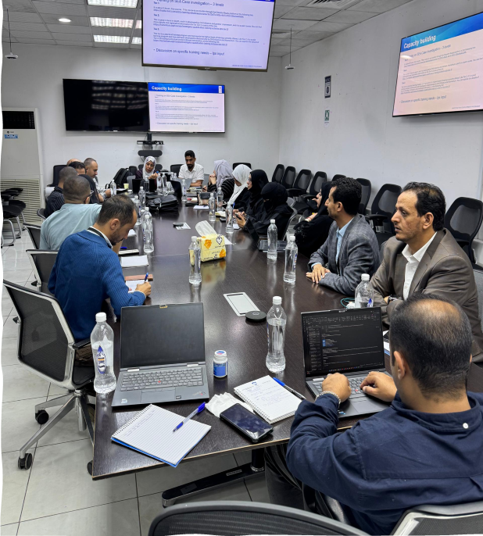
UNDP and its IPs advanced women’s economic inclusion through targeted initiatives under ESPECRP. In February 2025, UNDP held a dedicated workshop to validate socially acceptable and physically appropriate CFW activities for women and PWDs, expanding their livelihood options. Further, in June 2025, UNDP encouraged IPs to engage women contractors by reserving a percentage of community contracting projects exclusively for them, thereby, enhancing gender-equitable access and fair competition.
Monthly coordination meetings emphasized the geobundling approach to align complementary interventions for greater impact and sustainability. UNDP promoted tailored coaching and technical support to help women build skills, access local markets, and graduate into resilience pathways through nutrition programs, VSLAs, E-wallets, and MSME support via SMEPS and YLG.
A workshop held by UNDP in Sana’a to discuss gaps and solutions to gender equality
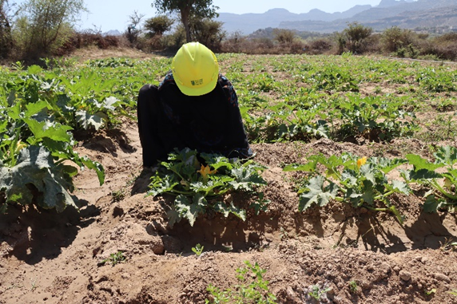
Since project inception, 17,762 women (30 percent of CFW beneficiaries) have participated in appropriate activities such as home gardening, land rehabilitation, and mud latrine construction. Under the CFN component, 141,699 mothers and 207,240 children—including those with disabilities—have received essential support, while 4,901 women gained temporary employment as health educators.
Ensuring workers safety through robust safeguards, creating a secure environment for all
To expand access to finance, UNDP introduced VSLAs and tailored support for women-led businesses. Under the YLG component, 2,510 women-led enterprises were supported, and the share of women beneficiaries rose to 37 percent under AF2. Proposed enhancements under AF3—including up to 90 percent guaranteed loan coverage—aim to further incentivize MFIs to serve women entrepreneurs.
On the protection front, UNDP nominated staff from three IPs for SEA/SH investigation training under the IQTS, in partnership with CHS Alliance, to strengthen partners’ capacity to address SEA/SH grievances confidentially and professionally.
Gender Mainstreaming Activities by the IPs
SFD: From January to June 2025, SFD delivered refresher training on the updated SEA policy to 740 personnel (including 110 women) staff, engineers, and contractors- to strengthen the prevention and mitigation of sexual exploitation and abuse. Additionally, 899 awareness sessions on the Code of Conduct and PSEA risks reached over 30,000 participants, including workers, engineers, contractors, and community committee members.
Since project inception, public consultations engaged 4,772 community members, resulting in 373 community committees with 43.7 percent female membership. SFD prioritized gender-sensitive measures—such as flexible working hours and women’s protection at worksites—to boost women’s participation. Five field visits monitored progress on gender mainstreaming and safety. Interviews with 18 women workers showed 100 percent felt safe, 93 percent had their concerns addressed, 92 percent received adequate work facilities, 99 precent contributed to needs assessments, and all attended grievance redress and complaint awareness sessions.
PWP: During the reporting period, PWP conducted 289 awareness and training sessions on gender and GBV/SEA prevention, reaching 3,741 participants (including 277 women)—including staff, engineers, workers, and community committee members. Nine public consultations engaged 221 community members (27 women) and led to the formation of nine committees with 21 percent women representation.
PWP actively promoted women’s inclusion across roles. Since project inception, 695 women have been employed as engineers, laborers, and technical consultants, and 10 women have been engaged as community contractors. A dedicated workshop was held to expand women’s participation in community contracting, identifying culturally appropriate activities for future implementation.
SMEPS: SMEPS delivered targeted training on gender mainstreaming and GBV/SEA prevention in five governorates, reaching 35 consultants and 70 beneficiaries. GRM training was also provided to 243 consultants (including 80 women) and 57 beneficiaries (3 women) across livelihoods, entrepreneurship, and private sector initiatives.
32 consultation sessions were held in eight governorates with 222 participants, while 1,039 individuals (37 percent women) received direct grants and technical support—including 600 under livelihoods, 382 entrepreneurs, and 57 from the private sector. Notably, women represented 100 percent of beneficiaries in livestock and midwifery, and 82 percent of female refugees were supported.
SMEPS prioritized inclusion of persons with disabilities and highly vulnerable individuals, enabling them to transition from dependency to sustainable livelihoods. In partnership with UNDP and the World Bank, SMEPS conducted consultations to identify barriers to women’s economic participation and guide pilot area selection for inclusive programming. Coordination with other IPs aims to ensure a harmonized and high-impact approach.

Communication & Visibility Plan
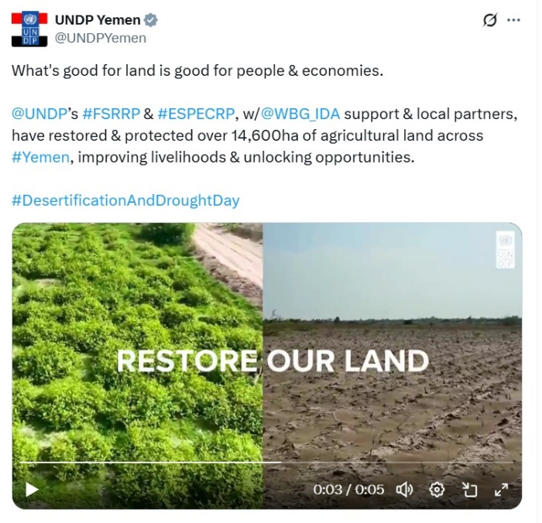
During the reporting period, different interventions of ESPECRP were highlighted to raise awareness among the public and key stakeholders about its key work in enhancing food security resilience and sustainable recovery. By leveraging digital platforms (e.g. X, Facebook, and Instagram) and web-based exposure stories, ESPECRP was featured through real-time updates, visual stories, and in-depth narratives in both Arabic and English to ensure broader reach and relevance.

As part of its outreach efforts, UNDP Yemen continued to recognize and celebrate its strategic partnership with the World Bank’s IDA and Yemen’s national institutions (SFD, PWP, SMEPS). Between January and June 2025, ESPECRP’s visibility activities spanned diverse thematic areas and international observances, showcasing the project’s vital role in fostering resilience, promoting health, advancing environmental sustainability, and driving economic recover.

International observances provided key opportunities to highlight ESPECRP’s achievements and impact. On Desertification and Drought Day (17 June 2025), the project underscored its contributions to combating desertification and promoting sustainable land management. Through two short videos in Arabic and English, ESPECRP effectively illustrated how its interventions help communities adapt to climate challenges, protect livelihoods, and strengthen long-term resilience.

ESPECRP was also featured on World Environment Day (June 5, 2025) for rehabilitating nearly 1,500 meters of sanitation networks and constructing over 6,670 household latrines across Yemen. ESPECRP’s environmental protection efforts are vital for building a cleaner environment and contributing to healthier and more sustainable living conditions for households and communities.
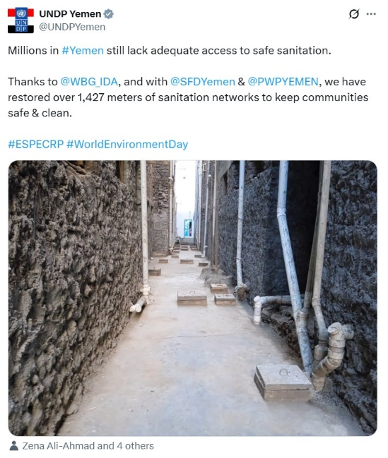
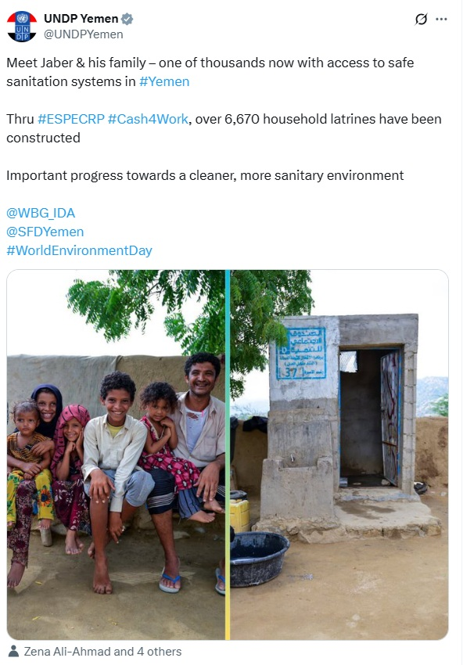
As a part of the geo-bundling approach, both ESPECRP and FSRRP were highlighted during Earth Day (April 22, 2025) for protecting and rehabilitating over 10,700 hectares of agricultural lands so far to improve food security. The message emphasized sustainable practices integral to building community resilience against evolving climate challenges and demonstrated the collective, holistic approach to food security resilience.
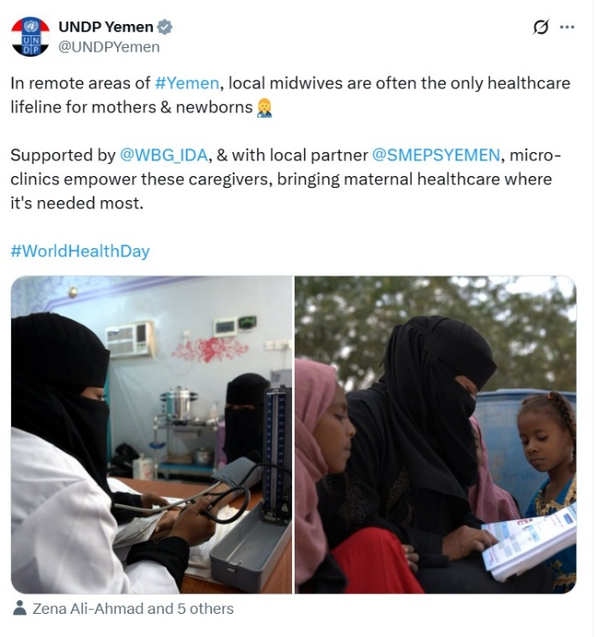
ESPECRP's vital contributions to strengthening health outcomes and improving community well-being were a central theme of the visibility agenda, particularly highlighted around World Health Day (April 7, 2025). An in-depth exposure story was published highlighting the life-saving contributions of midwives and how ESPECRP's support empowers these frontline healthcare providers to improve maternal and child health outcomes in underserved and remote areas. In parallel, ESPECRP was also highlighted for its key support of prevention and early detection of child malnutrition through empowering over 4,500 female health educators.

UNDP Yemen published a video highlighting ESPECRP’s and FSRRP’s joint work in Al-Majhafah, Lahj, demonstrating how integrated development approaches are fostering active community participation and yielding multiple, interconnected benefits for the local populations. This holistic model significantly contributes to improving sustainable livelihoods and agriculture and essential services.

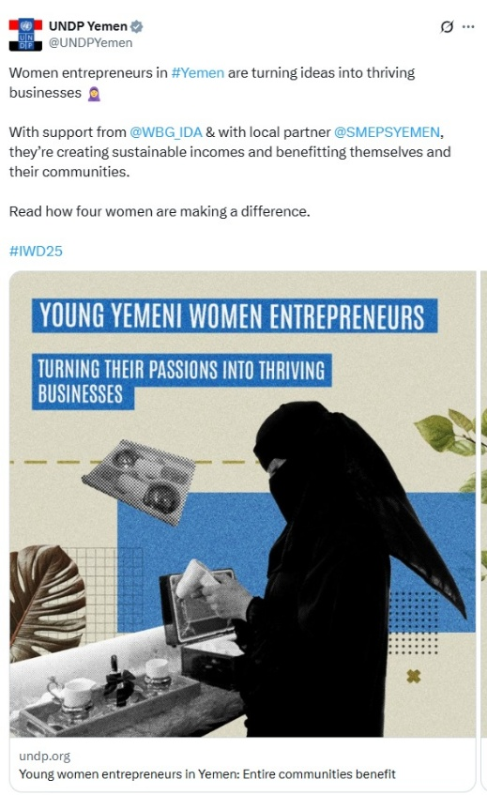
On International Women’s Day, UNDP Yemen featured four young women entrepreneurs supported by SMEPS through ESPECRP. The story showcased how the project's financial and technical assistance empowers these women to successfully launch, run, and grow their businesses. This directly contributes to revitalizing local economies and benefiting entire communities.

A video was also featured by UNDP Yemen about ESPECRP’s support to empowering women through community contracting. This approach emphasizes how empowering local communities through direct involvement in project implementation and oversight leads to sustainable development and ownership. This collectively highlights the multifaceted impact of this significant partnership.
As of June 2025, UNDP, together with SFD, SMEPS, and PWP, has published fifty-two videos / animations highlighting the ESPECRP’s work and impact garnering over 125,512 views online. In addition, 448 main social media posts have been published so far (10,272+ likes; 2,103+ shares) with over 382,503 views.

Key Actions/Activities for the Next Reporting Period (July to December 2025)

The table below summarizes the key actions that IPs and UNDP plan to complete by the end of the next reporting period in December 2025:
Subcomponent / RP | Actions
COMPONENT 2
2.1 Cash for Nutrition | - Under AF, SFD will:  - Complete the cash assistance and related nutrition education sessions to the eligible women in the remaining two districts (Hamdan and AlHusha).  - Under AF2:  - Start cash assistance in three new subdistricts and follow up on the referral services in the other 16 subdistricts.  - Coordinate closely with VSLAs and the other relevant activities for geobundling.
2.2 Cash for Work / SFD | - SFD will complete the remaining works of the 66 ongoing subprojects under the AF (52 of which have achieved over 90 percent financial progress).  - Under AF2, SFD will advance implementation of the ongoing 59 subprojects and finalize the technical studies and safeguard plans for the remaining uncommitted amount (around $2 million).  - SFD will actively contribute to geobundling coordination and ensure compliance to the project requirements.
2.3 Community Assets/ PWP | - Under AF, PWP will proceed with the implementation of 94 subprojects, of which 32 are community contracting.  - Under AF2, PWP will continue progressing the implementation of the ongoing 61 subprojects (including 23 community contracting) and will finalize the technical studies and safeguard plans for around 20 subprojects.  - PWP will continue contributing to the geobundling approach, supervising the implementation and ensuring compliance to safeguards.
2.4(a) YLG Subgrant, VSLAs, MFI Support / SFD (SMED) | - SFD will establish 40 new VSLAs, providing them with necessary supplies and trainings.  - Build the capacity of 800 new and existing VSLA members.  - Support 100 current VSLA members to start or expand income-generating activities (SMEs).
2.4(b)MSMEs (Farmers, Fishermen, Livestock), BAs SMEPS | Under AF, SMEPs will:  - Complete grant disbursement for 11 refugee entrepreneurs and continue entrepreneurship training for the initially selected entrepreneurs.  - Provide financial support to 144 rural clinics operated by midwives.  - Organize three promotional workshops and an exhibition to showcase the outcomes of first-phase grant-funded projects, highlight success stories, and connect entrepreneurs with financing institutions and investors.  Under A2F, SMEPs will:  - Initiate grant disbursement for 120 entrepreneurs in Sana'a and Amran and begin grant disbursement for around 21 entrepreneurs in Sana'a.
COMPONENT 3: Project Management, Monitoring, Evaluation and Capacity Building of National Institutions
UNDP | - UNDP will follow up on the agreed actions of the recent ISM.  - UNDP will finalize the contract with the new TPMA and conduct two TPM missions to a sample of sites.  - UNDP will complete planned capacity activities for the IPs as per the institutional capacity building (ICB) plans.  - On communication and visibility, UNDP – in collaboration with SFD, SMEPS, and PWP - plans to publish the following:  - An in-depth exposure story on strengthening local food supply chains.  - An explainer animation on how ESPECRP’s supported Village Savings and Loan Association are created to enhance food security resilience through improving access to finance and income-generating activities in rural communities.  - Six stories featuring young entrepreneurs who received technical and financial support.  - UNDP will prepare for the upcoming ISM (tentatively scheduled for the beginning November 2025) with the IPs and the WB.
Geobundling Approach | - Follow up and coordinate with IFPRI to initiate the implementation of the GB impact evaluation in the South.  - Conduct at least three meetings of the GB Central Working Group to review progress, coordination, challenges, and lessons learned.  - Conduct two field visits by the TPM and at least one by the UNDP team to GB sites and discuss findings and recommendations with the IPs.

Risk Framework and Risk Mitigation Measures

Systematic Operations Risk-Rating Tool
Risk Category | Rating | Update
Political and Governance | High | - Political volatility and operational risks in Houthis-controlled areas intensified during the reporting period. In March 2025, the U.S. re-designated Houthi as a Foreign Terrorist Organization (FTO), triggering expanded legal, financial, and compliance risks for ESPECRP operations. These include banking disruptions and heightened scrutiny of all financial flows. Further, the detention of UN staff in February and June 2025, including eight staff in Sa’ada, led to an UN-wide suspension of operations in that governorate. Escalating Red Sea hostilities and Israeli retaliatory strikes have compounded regional insecurity. UNDP is maintaining close coordination with other UN agencies and is conducting regular risk assessments and contingency planning to safeguard continuity of operations.
Macroeconomic | High | - Yemen’s ongoing shortage of hard currency, coupled with a fragmented and fragile banking system, continues to pose operational risks to ESPECRP delivery. The de-licensing of six banks by CBY-Aden, U.S. sanctions on Yemen Kuwait Bank (YKB), and the FTO designation have disrupted fund flows, reduced access to safe banking channels, and led commercial banks to impose liquidity charges of up to 1.75% on USD transactions. These constraints have caused delays in fund transfers, limited liquidity for implementing partners, and disrupted procurement and payment cycles. To mitigate these impacts, UNDP is leveraging multiple financial channels, pre-positioning funds, adjusting payment schedules, and absorbing some liquidity charges where necessary, while maintaining close coordination the World Bank to safeguard operational continuity.  - The SDR exchange loss (USD$6 million in total) continues to impact both project budget and delivery. UNDP has adopted adaptive financial modalities, shifted to non-sanctioned banks (KIB, YCB), and is finalizing a new banking arrangement to sustain operations.
Technical Design of Project or Program | Substantial | - The geobundling approach remains central to layered service delivery but has faced delays due to perceived imbalances in fund distribution and intensive coordination needs. These have at times generated dissatisfaction among authorities. To address this, UNDP and IPs have enhanced transparency with stakeholders, coordinated with other donors to expand geographic coverage, and integrated conflict-sensitive and participatory planning approaches to improve ownership, equity, and sustainability. The model continues to offer strategic value in optimizing impact across high-need areas.
Institutional Capacity for Implementation and Sustainability | Medium | - Access restrictions and data-sharing limitations in Houthi-controlled areas have constrained implementation and monitoring. TPMA activities were adapted to avoid sensitive questions, and IFPRI’s impact evaluation has been revised to focus on the Southern/IRG areas. Restrictions on women’s movement remain a challenge, particularly for field verification. UNDP is working with IPs to refine context-sensitive monitoring tools and strengthen institutional capacities. Continued investments in safeguards, digital tools, and flexible implementation modalities are helping ensure adaptive delivery.
Fiduciary | High | - Fiduciary risks have increased due to the banking crisis, FTO-related sanctions, and shifting financial compliance obligations. UNDP has responded by transitioning to trusted banking partners (e.g., KIB and YCB), reducing reliance on cash advances, and adopting direct payment/reimbursement mechanisms. Despite the disruption, procurement and disbursement performance remains satisfactory. The pending issue of blocked funds at YKB (US$1.03 million) is under active resolution, with UNDP pursuing a mix of negotiations, exemptions, and alternative banking routes. Regular monitoring, spot checks, internal controls, and TPMs continue to ensure fiduciary compliance. Engagement with the World Bank on unresolved issues remains ongoing.
Environment and Social | Substantial | - E&S risks remain significant, especially in fragile areas where exclusion, child labor, GBV, and land disputes are prevalent. While most ESPECRP interventions are small-scale, occupational safety risks require ongoing vigilance. Stronger safeguards systems and staff training have been institutionalized across IPs. However, the length of safeguard preparation and clearance – often exceeding planned timelines – has delayed project rollouts and created reputational risks. UNDP and the World Bank are working to streamline clearance procedures, targeting a two-week timeline. Field visits and TPMA reports continue to ensure compliance and enhance social accountability.
Stakeholders | Substantial | - Operational risks related to stakeholders, particularly in Houthi areas, persist due to arrests of humanitarian personnel and volatile community dynamics. Nevertheless, UNDP and IPs have sustained implementation by using conflict-sensitive messaging, maintaining transparency, and leveraging the longstanding trust of national IPs with local authorities. Community engagement structures, such as VCCs and SDDCs, have continued to function and support grassroots planning and implementation. Adaptive communication strategies remain key to managing expectations and minimizing friction.
OVERALL | High | - ESPECRP continues to operate in a highly complex and volatile context characterized by escalating political tensions, financial instability, and access restrictions. Despite these risks, the project has shown resilience through timely mitigation measures, adaptive modalities, and strong engagement with partners. Continued donor coordination, strategic flexibility, and robust risk management will remain essential to ensure continued delivery and institutional gains under the project.

ANNEXES:

Annex 1: Results Framework

PDO Level Indicators | (IPs) | Unit | Baseline | Total Targets PF+AF+AF2 | Progress as of (30 June 2025) | % results vs targets
Provision of Cash Transfers
Number of beneficiary households benefitting from the cash for nutrition program | SFD | Number | 0 | 106,500 | 131,062 | 123.1%
Number of beneficiary households (Social Welfare Fund) | SFD | Number | 0 | 9,300 | 8,357 | 89.9%
Number of beneficiaries (women) | SFD | Number | 0 | 111,600 | 141,699 | 127.0%
Number of beneficiaries (children) |  | Number | 0 | 153,000 | 207,240 | 135.5%
Provision of temporary employment
Number of direct beneficiaries of wage employment | SFD & PWP | Number | 0 | 155,208 | 100,058 | 64.5%
Number of beneficiaries (women-at least 20%) | SFD & PWP | Number | 0 | 33,710 | 29,264 | 86.8%
Number of beneficiaries (IDPs - at least 15%) | SFD & PWP | Number | 0 | 22,281 | 9,782 | 43.9%
Increased access to basic services and economic opportunities to vulnerable populations
Number of people with increased access to basic services | SFD & PWP | Number | 0 | 1,122,880 | 1,170,063 | 104.2%
Of which, women (at least 50%) | SFD & PWP | Number | 0 | 528,397 | 585,032 | 110.7%
Number of Micro, Small and Medium Enterprises (MSME's) supported by the Project | (SMEPS & SMED) | Number | 0 | 10,009 | 9,459 | 94.5%
Number of women-led SMEs supported by the project (at least 35%) | (SMEPS & SMED) | Number | 0 | 2,778 | 2,487 | 89.5%
People provided with access to improved sanitation services to reduce water-borne diseases exacerbated by climate change | SFD & PWP | Number | 0 | 272,845 | 109,427 | 40.1%
Intermediate Results Indicators by Subcomponents
Subcomponent 2.1: Cash Transfers (Cash for Nutrition)
Number of women beneficiaries of wage employment | SFD | Number | 0 | 3,920 | 4,901 | 125.0%
Number of indirect beneficiaries of wage employment | SFD | Number | 0 | 23,520 | 29,406 | 125.0%
Subcomponent 2.2: Labor Intensive Works and Economic Opportunities
2.1 Cash for Work (SFD)
Number of direct beneficiaries of wage employment | SFD | Number | 0 | 77,700 | 56,151 | 72.3%
Number of beneficiaries (women) (30%) | SFD | Number | 0 | 23,310 | 17,762 | 76.2%
Number of indirect beneficiaries of wage employment (family members of direct beneficiaries) (cash for work) | SFD | Number | 0 | 372,312 | 336,906 | 90.5%
Number of people with increased access to basic services | SFD | Number | 0 | 452,750 | 454,837 | 100.5%
Cubic meters of water schemes constructed/rehabilitated (Cubic Meter(m3)) | SFD | m3 | 0 | 46,066 | 33,807 | 73.4%
Area of agriculture land rehabilitated Hectare | SFD | ha | 0 | 2,477 | 3,949 | 159.4%
Length of roads improved (Kilometers) | SFD | km | 0 | 209 | 249 | 119.4%
Subcomponent 2.3: Community Assets (PWP)
Number of direct beneficiaries of wage employment | PWP | Number | 0 | 51,993 | 23,876 | 45.9%
Number of women beneficiaries (3%) | PWP | Number | 0 | 2,167 | 649 | 29.9%
Number of indirect beneficiaries of wage employment | PWP | Number | 0 | 311,958 | 166,600 | 53.4%
Number of people with increased access to basic services | PWP | Number | 0 | 670,130 | 715,226 | 106.7%
Cubic meters of water schemes constructed/rehabilitated (Cubic Meter(m3)) | PWP | Number | 0 | 147,402 | 78,287 | 53.1%
Area of agriculture land rehabilitated Hectare | PWP | Number | 0 | 5,012 | 3,586 | 71.6%
Length of roads improved (community assets) (Kilometers) | PWP | Number | 0 | 163 | 69 | 42.6%
2.4a Increased Access to finance for MSMEs (SFD/SMED)
Number of MFIs to access the new YLG portfolio guarantee scheme | SFD (SMED) | Number | 0 | 6 | 6 | 100.0%
Number of SME loans guaranteed by the new capitalization to the YLG | SFD (SMED) | Number | 0 | 3,754 | 5,182 | 138.0%
Number of Village Saving and Loans Associations | SFD (SMED) | Number | 0 | 715 | 690 | 96.5%
2.4b Direct support to MSMEs and business associations in critical sectors (SMEPS)
SMEs receiving TA and grants that produce and facilitate food distribution | SFD (SMEPS) | Number | 0 | 6,255 | 4,210 | 67.3%
Business associations supported in the target sectors directly through grants and TA | SFD (SMEPS) | Number | 0 | 50 | 67 | 134.0%
Number of new seasonal and permanent wage employment supported | SFD (SMEPS) | Number | 0 | 21,595 | 29,388 | 136.1%
Component 3: Project Management, Monitoring, Evaluation and Capacity Building of National Institutions
Surveyed beneficiaries who report receiving the right payment amount | UNDP | % | 0 | 98 | 100
Grievances received, addressed, and responded to within a timeline that has been specified and publicly communicated by the project | UNDP | % | 0 | 90 | 98
Surveyed beneficiaries who express satisfaction with project interventions (UNDP) (Percentage) | UNDP | % | 0 | 80 | 92
Capacity building action plan for SFD adopted and implemented | UNDP | Yes/No | No | Yes | In progress
Capacity building action plan for PWP adopted and implemented | UNDP | Yes/No | No | Yes | In progress

Annex 2: Annual Progress (Expenses and Direct Beneficiaries) per Subcomponent

Annual Disbursement | 2021 | 2022 | 2023 | 2024 | 2025
CFN | 2,729,294 | 10,967,321 | 11,526,193 | 10,172,943 | 4,558,758
CFW | 66,129 | 9,932,831 | 1,782,956 | 7,659,668 | 5,958,728
Community Assets | 1,069,093 | 8,619,519 | 3,402,319 | 4,259,977 | 1,721,855
YLG/VSLAs/MFIs/MSMEs | 2,529,217 | 4,177,026 | 2,148,991 | 4,017,359 | 1,004,968
Goods, works, consulting, non-consulting, Operating Costs | 4,916,050 | 8,014,521 | 9,779,543 | 9,653,024 | 5,391,726
Annual RRF | 2021 | 2022 | 2023 | 2024 | 2025
CFN | Mothers= 24036 | Mothers= 41101 | Mothers= 32096 | Mothers= 44177 | Mothers= 4901
CFN | CHEs=484 | CHEs=1252 | CHEs=1216 | CHEs=1927 | CHEs=366
CFW | Works:  0 | Workers: 19813 | Workers: 3720 | Workers: 31618 | Workers: 13142
Community Assets | Workers: 1372 | Workers: 8931 | Workers: 3723 | Workers: 9850 | Workers: 4950
YLG/VSLAs/MFIs/MSMEs | MSMEs= 265 | MSMEs= 3399 | MSMEs= 1435 | MSMEs= 2913 | MSMEs= 193
YLG/VSLAs/MFIs/MSMEs | VSLAs=31 | VSLAs=0 | VSLAs=223 | VSLAs=414 | VSLAs=71

Annex 3: Subcomponent Intermediary RRF by Financing Agreemen, as of 30 June 2025

Subcomponent | Target | Achieved | Target | Achieved | Target | Achieved | Target | Achieved
Subcomponent 2.1 CFN Indicators | PF Targets | % PF Result | AF Targets | % AF Result | AF2 Target | % AF2 Result | Total Targets | Total Result | % Result
Number of beneficiary households benefitting | 23,000 | 181% | 38,500 | 168% | 45,000 | 55% | 106,500 | 131,062 | 123.1%
Number of beneficiaries HHs (SWF) | 2,300 | 134% | 3,850 | 92% | 3,150 | 55% | 9,300 | 8,357 | 89.9%
Number of beneficiaries (mothers) | 23,000 | 193% | 40,600 | 174% | 48,000 | 56% | 111,600 | 141,699 | 127.0%
Number of beneficiaries (children) | 27,600 | 231% | 62,400 | 167% | 63,000 | 63% | 153,000 | 207,240 | 135.5%
Number of female beneficiaries of wage employment | 920 | 118% | 1,400 | 185% | 1,600 | 76% | 3,920 | 4,901 | 125.0%
Number of indirect beneficiaries of wage employment | 5,520 | 118% | 8,400 | 185% | 9,600 | 76% | 23,520 | 29,406 | 125.0%
Subcomponent 2.2 CFW Intermediary indicator | PF Targets | % PF Result | AF Targets | % AF Result | AF2 Target | % AF2 Result | Total Targets | Total Result | % Result
Number of direct beneficiaries of wage employment | 21,500 | 98% | 38,000 | 78% | 18,200 | 29% | 77,700 | 56,151 | 72.3%
Number of women benefit. (30%) | 6,450 | 102% | 11,400 | 76% | 5,460 | 46% | 23,310 | 17,762 | 76.2%
Number of indirect beneficiaries of wage employment | 129,000 | 98% | 165,312 | 108% | 78,000 | 41% | 372,312 | 336,906 | 90.5%
Number of people with increased access to basic services | 138,500 | 214% | 220,000 | 67% | 94,250 | 12% | 452,750 | 454,837 | 100.5%
Cubic meters of water schemes constructed/rehabilitated (m3) | 20,746 | 37% | 18,300 | 142% | 7,020 | 2% | 46,066 | 33,807 | 73.4%
Area of agriculture land rehabilitated Hectare | 879 | 49% | 1,000 | 318% | 598 | 55% | 2,477 | 3,949 | 159.4%
Length of roads improved (km) | 45 | 195% | 92 | 174% | 72 | 1% | 209 | 249 | 119.4%
Subcomponent 2.3 CA Intermediary indicator | PF Targets | % PF Result | AF Targets | % AF Result | AF2 Target | % AF2 Result | Total Targets | Total Result | % Result
Number of direct beneficiaries of wage employment | 16,940 | 76% | 25,173 | 44% | 9,880 | 0% | 51,993 | 23,876 | 45.9%
Number of female benefit (3%) | 508 | 113% | 1,259 | 6% | 400 | 0% | 2,167 | 649 | 29.9%
Number of indirect beneficiaries of wage employment | 101,640 | 88% | 151,038 | 51% | 59,280 | 0% | 311,958 | 166,600 | 53.4%
Number of people with increased access to basic services | 255,000 | 177% | 291,330 | 91% | 123,800 | 0% | 670,130 | 715,226 | 106.7%
Cubic meters of water schemes constructed/rehabilitated (m3) | 57,000 | 115% | 63,042 | 20% | 27,360 | 0% | 147,402 | 78,287 | 53.1%
Hectare of Agri land rehabilitated | 1,600 | 160% | 2,522 | 41% | 890 | 0% | 5,012 | 3,586 | 71.6%
Length of roads improved (km) | 38 | 128% | 66 | 31% | 59 | 0% | 163 | 69 | 42.6%
Subcomponent 2.4 MSMEs Intermediary indicator | PF Targets | % PF Result | AF Targets | % AF Result | AF2 Target | % AF2 Result | Total Targets | Total Result | % Result
Number of MFIs to access the new YLG portfolio guarantee scheme | 3 | 100% | 2 | 100% | 1 | 100% | 6 | 6 | 100.0%
Number of SME loans guaranteed by the new capitalization to the YLG | 3,024 | 105% | 0 | 0% | 730 | 274% | 3,754 | 5,182 | 138.0%
Number of VSLAs | 30 | 150% | 500 | 100% | 185 | 66% | 715 | 690 | 96.5%
SMEs receiving TA and grants that produce and facilitate food distrib. | 1,630 | 103% | 3,200 | 0% | 1,425 | 0% | 6,255 | 4,210 | 67.3%
Business associations supported through grants and TA | 20 | 100% | 30 | 47% | - | 0% | 50 | 67 | 134.0%
Number of new seasonal & permanent wage employment | 8,320 | 182% | 9,600 | 0% | 3,675 | 0% | 21,595 | 29,388 | 136.1%

Annex 4: Communication and Visibility Reference Links

All visibility videos can be accessed from this link: https://www.dropbox.com/sh/7mwhellqnhnf8l2/AAAIyGxf-EolOf3aiBGWfKLRa?dl=0

Title | Links
#DesertificationAndDroughtDay | X  AR:  https://x.com/UNDPYemen/status/1935050858963587204  https://x.com/UNDPYemen/status/1935407586137829458  https://x.com/UNDPYemen/status/1936799764018053247  EN:  https://x.com/UNDPYemen/status/1935020720897053048  https://x.com/UNDPYemen/status/1935394133431984379  https://x.com/UNDPYemen/status/1936755778901426218
#WorldEnvironmentDay | X  AR:  https://x.com/UNDPYemen/status/1930310529094168739  https://x.com/UNDPYemen/status/1931453580747092011  EN:  https://x.com/UNDPYemen/status/1930284609331208560  https://x.com/UNDPYemen/status/1931415319853277294  https://x.com/UNDPYemen/status/1931415421762089347
#EarthDay | X  AR:  https://x.com/UNDPYemen/status/1915027823900663903  https://x.com/UNDPYemen/status/1915454675148497139  EN:  https://x.com/UNDPYemen/status/1915008941345411508  https://x.com/UNDPYemen/status/1915421983451344907
#WorldHealthDay | X  Midwives  AR: https://x.com/UNDPYemen/status/1909278625616073145  EN:  https://x.com/UNDPYemen/status/1909205788679094637  https://x.com/UNDPCrisis/status/1920510318599434678  Exposure story  X  AR: https://x.com/UNDPYemen/status/1919365343253790784  EN: https://x.com/UNDPYemen/status/1919313987642052763  Website  AR: https://undpyemen.exposure.co/midwives25-ar?source=share-UNDPYemen  EN: https://undpyemen.exposure.co/midwives25?source=share-UNDPYemen
Cash for Nutrition | X  AR: https://x.com/UNDPYemen/status/1910040115931398165  EN: https://x.com/UNDPYemen/status/1910024080146772048
Geo-bundling: Al-Majhafa geo-bundling | X  AR: https://x.com/UNDPYemen/status/1877323874234142795  EN: https://x.com/UNDPYemen/status/1877286904191693127
WB-UNDP partnership | Water  AR: https://x.com/UNDPYemen/status/1879614146880344171  EN: https://x.com/UNDPYemen/status/1879581554395210054  Cash for nutrition  AR: https://x.com/UNDPYemen/status/1879951756324401656  EN: https://x.com/UNDPYemen/status/1879936661540512031  Economic resilience  AR: https://x.com/UNDPYemen/status/1881691099762405616  EN: https://x.com/UNDPYemen/status/1881663556858630168
Community contracting | Video  AR: https://x.com/UNDPYemen/status/1893644746985202036  EN: https://x.com/UNDPYemen/status/1893629311900360909
International Women’s Day (Young women entrepreneurs) | X  AR: https://x.com/UNDPYemen/status/1899192368886411395  EN: https://x.com/UNDPYemen/status/1899177267051561110  Story  AR: https://www.undp.org/ar/yemen/stories/raydat-alamal-fy-alymn-faydt-tum-aljmy  EN: https://www.undp.org/yemen/stories/young-women-entrepreneurs-yemen-entire-communities-benefit  https://x.com/UNDPArabic/status/1899502075702059122  https://x.com/UNDPCrisis/status/1900212887928369322
#WorldWaterDay | AR: https://x.com/UNDPYemen/status/1903932140762345814  EN: https://x.com/UNDPYemen/status/1903913127043019003

The project comprises three grants including the Parent Fund (PF) with a total amount of US$ 61.4 million signed on 23 December 2020, an Additional Financing (AF) of US$ 108 million signed on 13 April 2022, and a second additional financing (AF2) of US$ 63.5 million signed on 30 March 2023. The project closing date has been extended to December 31, 2026.
To meet the overwhelming demand for CFN in target communities, the project adjusted the benefit duration from 12 to 6 months for most beneficiaries, with the exception of women with malnutrition who continue to receive the full 12-month cycle. This adjustment allowed the project to extend support to a larger number of households, resulting in the indicator exceeding its target.
This indicator includes direct workers from all subcomponents (CFW, CFN, Community Assets and the additional jobs created by MSMEs)
This target comprises the number of MSMEs targeted by SMEPS, SMED and Yemen Loan Guarantee (YLG).
The total grant amounts in USD have been impacted by fluctuations in the SDR exchange rate, resulting in estimated losses as of the end of June 2025 of approximately $1.48 million under PF and around $4.5 million under AF. These gaps are proportionately reflected in the activity lines of the subcomponents under Component 2. The committed activities under PF were carried over to AF, while the activities under AF will be reviewed and decided upon at a later stage.
The bank interest generated under PF amounted to $376,551.49 which has been reported in the relevant Interim Financial Report (IFR). Under AF, the interest accrued is $52,247.38, which is planned to be used to pilot the e-wallet initiative with CFN. No further bank interest has been generated since March 2023, following the Houthis' decree banning bank interest.
The original PF amount was decreased by $1.48 Million due to SDR vs USD exchange rate loss.
The remaining balance ($0.31M) is under UNDP Management and will be requested partly in 2026 for final evaluation.
Around $10K bank interest is left under PF, which was agreed to support geobundling under AF and will be fully cleared next period.
As previously clarified, AF2 delays were due to the time needed for geobundling setup, procrastinated permit issues for needs assessments in Houthi areas, and slow safeguard clearances. With recent clearances, implementation has moved and plans for acceleration are underway.
Pregnant and lactating women, women with children under five or children with disabilities under seventeen in subdistricts with high levels of malnutrition and food insecurity.
Each mother receives an approximate monthly amount of US$ 30 to US$ 35, paid in YER and adjusted to the exchange rate to account for the significant disparity between the South and North.
Each woman CHE receives US$ 100 per month for a duration of 6 months in general, with some extended to 12 months, where needed, to support HHs identified with malnutrition.
CFW Diversified interventions comprise different types of relatively small activities prioritized by a community to engage as many people as possible in need within the available allocation in that target community. These may encompass a couple or more activities including home gardens, small water schemes, shelters, vocational training for women, small-lane pavement, among others.
Around US$ 500 per household involved in CFW wage employment over an average period of 4 months.
Earlier under the PF, SFD provided grants $38,000 to Azal and Hadhramout MFIs to enhance IT systems, resulting in modern data centers that improved security, efficiency, and all-day service accessibility, supporting digital financial inclusion.
To address the fluctuation of the exchange rate and the large disparity between the South and North more accurately, YLG developed a methodology to apply the prevailing rate at district level in the date of payment. The average exchange rate in the North was around YER560 and in the South was around YER1,225 over the reporting period.
A Village Savings and Loan Association is a group of around 25 individuals from a village who save amounts of money together in regular meetings and obtain small loans from these savings whenever there is sufficient money to start or expand their income-generating activities.
Occupational Health and Safety
Delay or non-payment of financial entitlements, including delay in payment to direct beneficiaries and contractors.
Grievances related to protecting the community from any harm resulting from interventions, such as community health and safety, misbehavior by any project personnel to the community member, infrastructure disruption, service interruptions as well as any damages to beneficiaries' properties.

